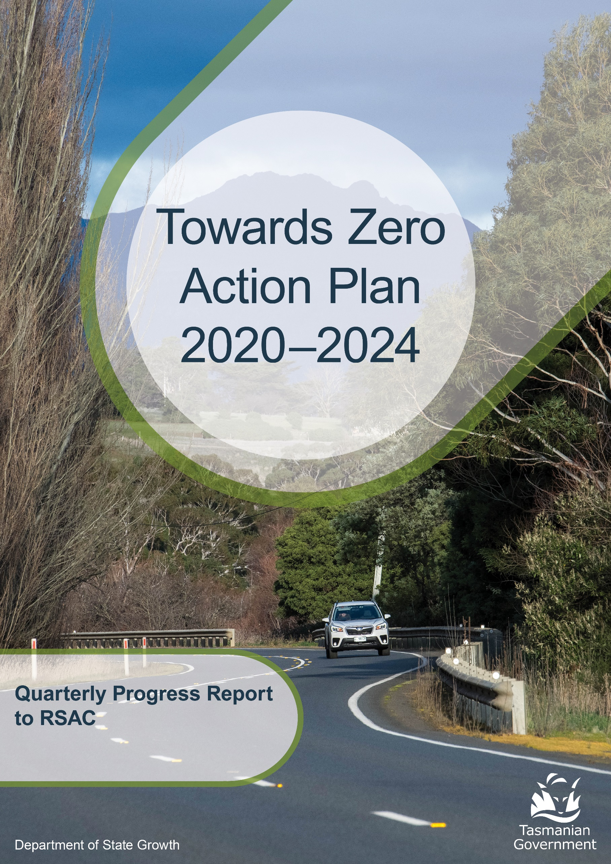
to 31 December 2025
Contents
Progress on meeting Towards Zero Strategy targets 3
Serious Casualties 3
Fatalities 3
Fatalities Tasmania – Annual Count 3
3
Serious Casualties Tasmania – Annual Count, Percentage Split by Quarter and Towards Zero Target 4
Annual fatalities – Rate per 100,000 population 4
Progress on meeting MAIB targets 5
Fatalities – 12 Month Rolling Total 5
Total Serious Claims – 12 Month Rolling Total 5
Statistics 6
Serious Casualties by Quarter by Age Group – 12 period moving average 6
Serious Casualties by Quarter by Sex – 12 period moving average 6
6
Serious Casualties by Quarter by Road User Type – 12 period moving average 7
Serious Casualties by Quarter by Speed Zone – 12 period moving average 7
Serious Casualties by Quarter by Crash Type (DCA) – 12 period moving average 8
Serious Casualties by Quarter by Urban/Non-Urban – 12 period moving average 8
Serious Casualty locations 2025 (Black = Fatality, Red = Serious Injury) 9
Key themes and priority actions 2020-2024 10
Funding of key themes 10
Project status report 11
Progress on key themes 12
Rural roads grants program for local government 12
Infrastructure upgrades on low volume State roads 13
Motorcyclist safety on rural roads 13
Speed management and community engagement strategy 14
Safe system knowledge and skills training 14
Targeted infrastructure upgrades in high traffic urban areas 15
Vulnerable Road User Program 15
Community Road Safety Grants Program 16
Trial of innovative technologies 16
Innovative infrastructure treatment demonstrations 17
Learner Driver Mentor Program and Driver Mentoring Tasmania 18
Graduated Licensing System Project 18
Motorcyclist Graduated Licensing System review 19
RYDA program 20
Driving for Jobs Program 20
RACT education initiatives 21
Real Mates media campaign 21
Bicycle Network bike education 22
Safety around schools 22
Kidsafe child restraint check program 22
Full Gear motorcycle safety project 23
RACT Youth Road Safety Program 23
Inattention and distraction 25
Safe behaviour campaigns 26
Mandatory Alcohol Interlock Program (MAIP) 27
Protective clothing for motorcyclists 27
Road safety penalties review 28
Speed enforcement strategy 28
Enforcement of high-risk behaviours 29
Automated Traffic Enforcement Program 29
High-risk motorcycling enforcement 30
Road Rules Awareness 30
Tourist road safety signage program 31
Responsive electronic signage trial 31
Tourist education materials 31
Strategic partnerships 32
Tourist education at gateway entry points 32
Stakeholder alliances 32
Australasian New Car Assessment Program (ANCAP) 33
Safer cars for young drivers 33
Autonomous vehicle and crash avoidance readiness 33
Workplace driver safety 34
Light vehicle safety strategy 34

Progress on meeting Towards Zero Strategy targets
The key interim target for the Towards Zero – Tasmanian Road Safety Strategy 2017-2026 (Towards Zero Strategy) is to reduce the number of annual serious injuries and deaths on Tasmanian roads to fewer than 200 by 2026. This is an ambitious target of 100 fewer serious casualties per year than for the period 2012-2016 (annual average) and will move us towards the long-term goal of zero serious casualties on Tasmanian roads.

Serious Casualties
The number of serious casualties in 2025 was 321, compared to 339 in 2024, a 5.3 per cent decrease. The 2025 figure of 321 is a 0.6 per cent decrease on the five year serious casualty average of 322.8 (2020-2024).

Fatalities
In 2025, there were 44 fatalities on Tasmanian roads which is 13 more than the number recorded in 2024. The figure of 44 fatalities in 2024 is a 16.4 per cent increase on the five-year fatality average of 37.8 (2020-2024).

Fatalities Tasmania – Annual Count
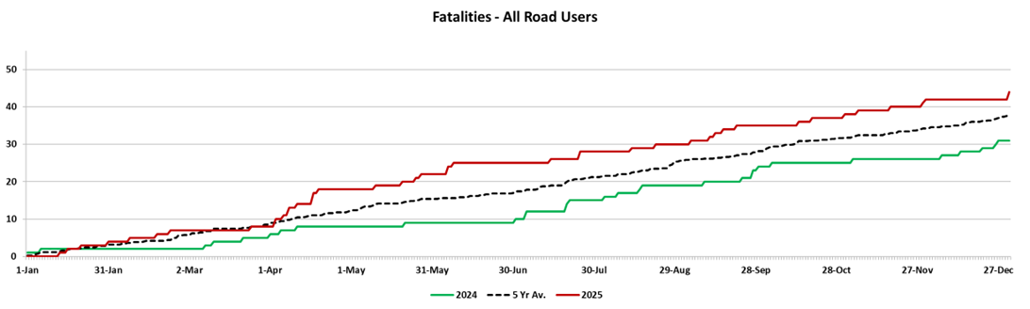

Serious Casualties Tasmania – Annual Count, Percentage Split by Quarter and Towards Zero Target
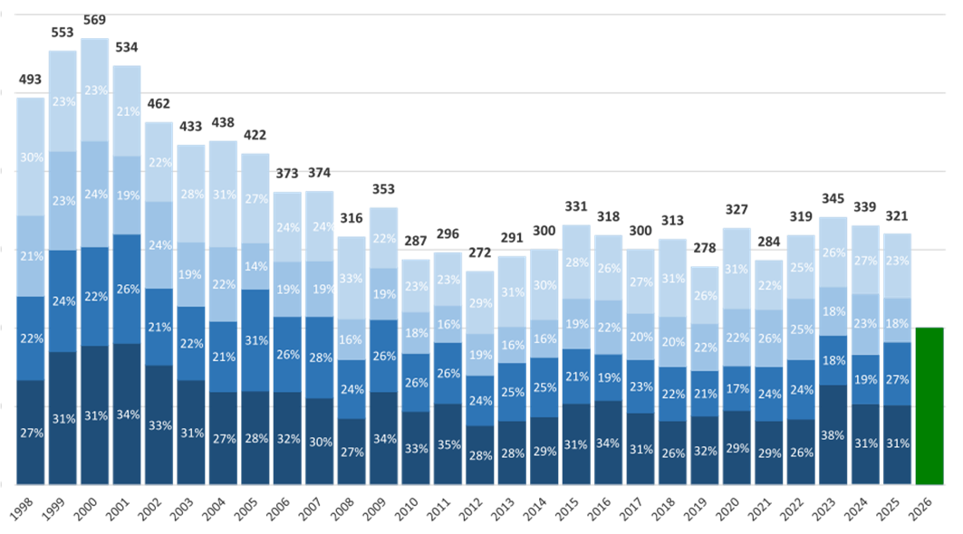

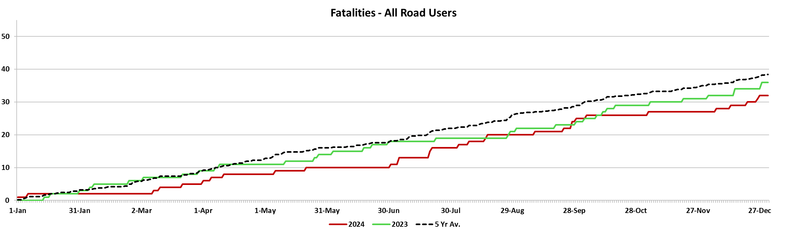

Annual fatalities – Rate per 100,000 population
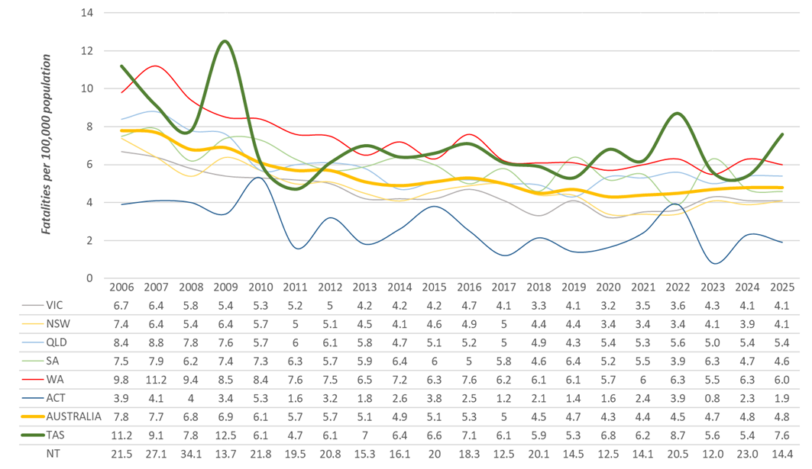

Note: NT omitted from chart for clarity purposes.

Progress on meeting MAIB targets
Motor Accidents Insurance Board (MAIB) injury statistics show the number of fatalities and the level of claims for serious injuries on our roads.
Various claim reduction targets are specified in the Memorandum of Understanding between the Department of State Growth (State Growth) and the MAIB. Progress against high level targets is shown below, expressed as 12 month moving totals.

Fatalities – 12 Month Rolling Total
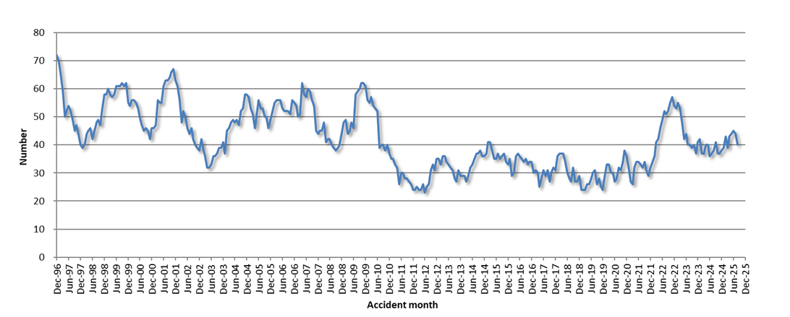

Total Serious Claims – 12 Month Rolling Total
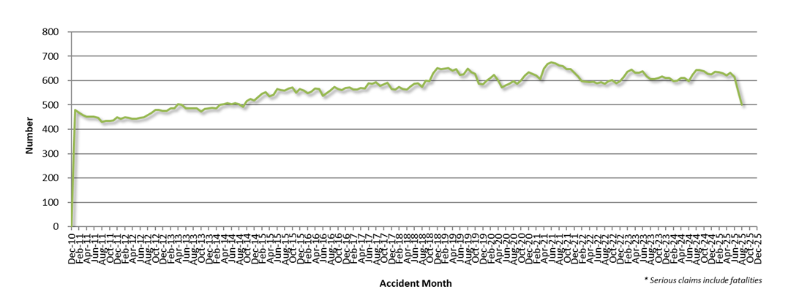

Statistics

Serious Casualties by Quarter by Age Group – 12 period moving average
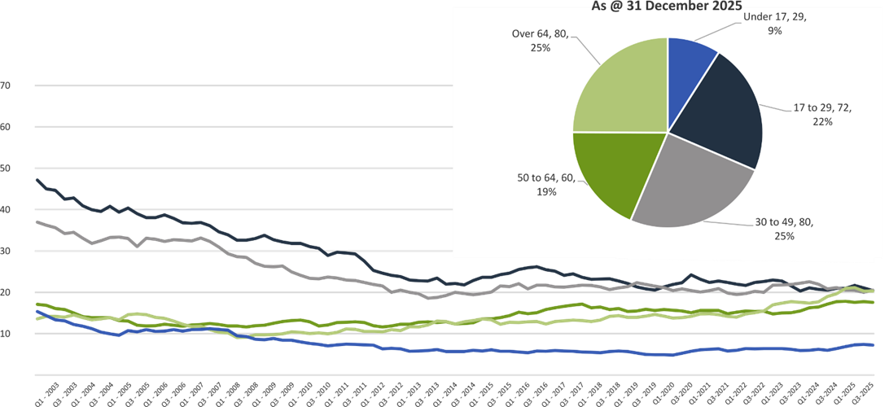

Serious Casualties by Quarter by Sex – 12 period moving average
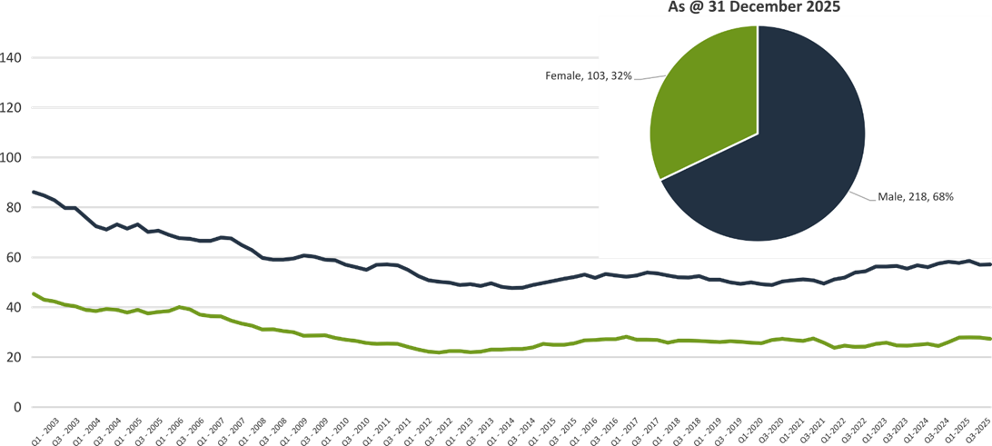

Serious Casualties by Quarter by Road User Type – 12 period moving average
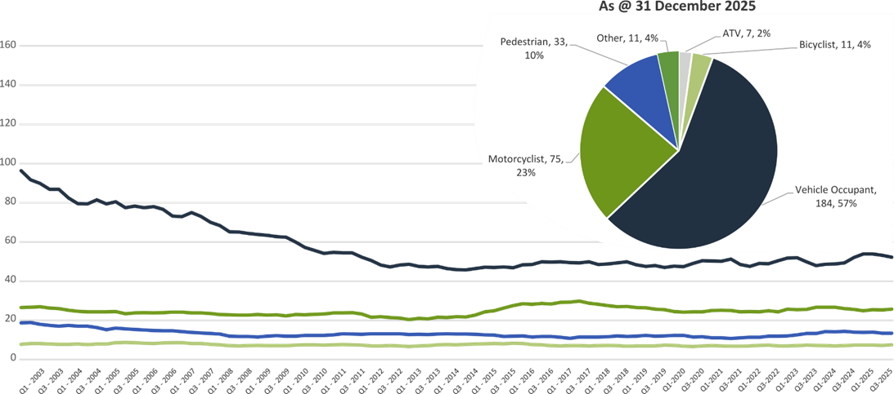

Serious Casualties by Quarter by Speed Zone – 12 period moving average
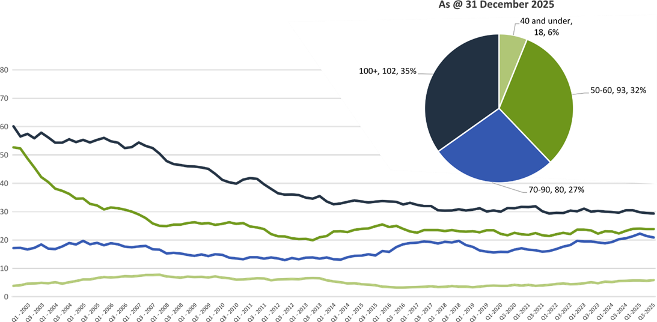

Pie chart excludes serious casualties where speed zone is recorded as ‘not known’

Serious Casualties by Quarter by Crash Type (DCA) – 12 period moving average
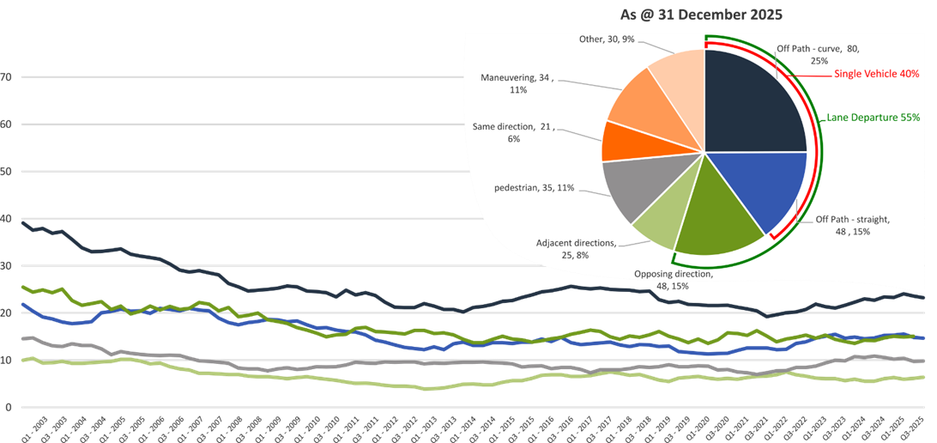

Other includes crash types: on-path (2%), overtaking (4%) & passenger and miscellaneous (4%).

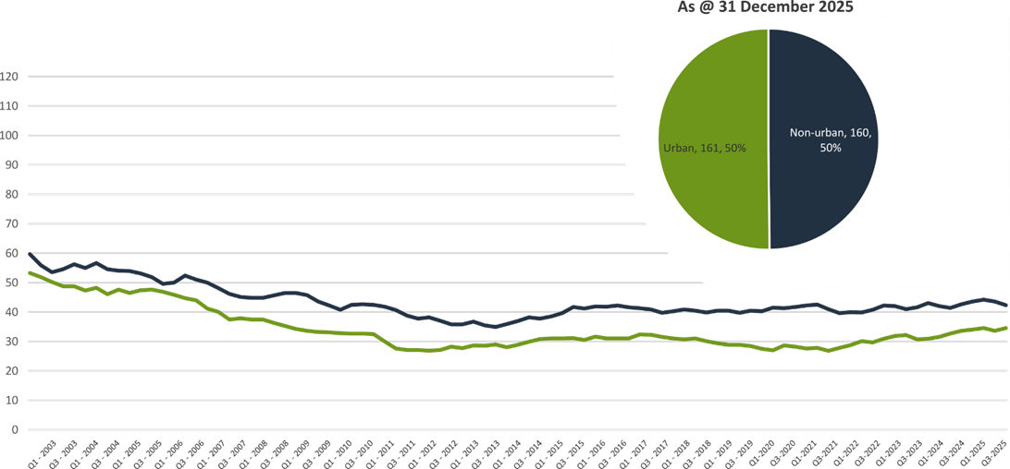
Serious Casualties by Quarter by Urban/Non-Urban – 12 period moving average

Based on the Australian Bureau of Statistics’ ‘significant urban area’ geographic definition.

Serious Casualty locations 2025 (Black = Fatality, Red = Serious Injury)
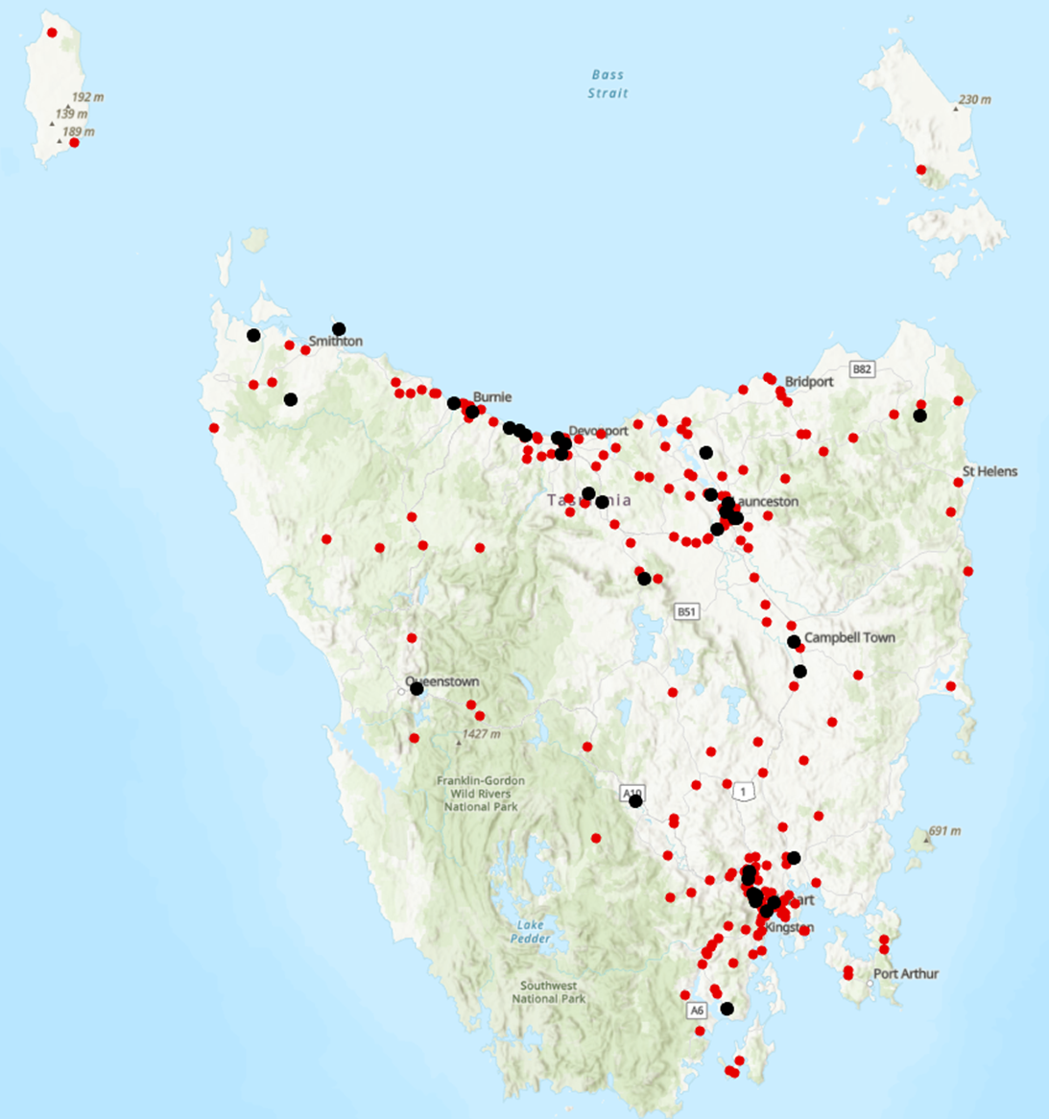

Key themes and priority actions 2020-2024
The Quarterly Progress Report details progress on key themes and priority actions under the Towards Zero Action Plan 2020-2024 and the Towards Zero – Tasmanian Road Safety Strategy 2017-2026.
The progress report should be read in conjunction with the Action Plan and understood in the context of the Towards Zero Strategy. These documents are available at: www.towardszero.tas.gov.au

Funding of key themes




Over $20 million Over $31 million
Over $12 million Over $4 million



$2 million Over $3 million

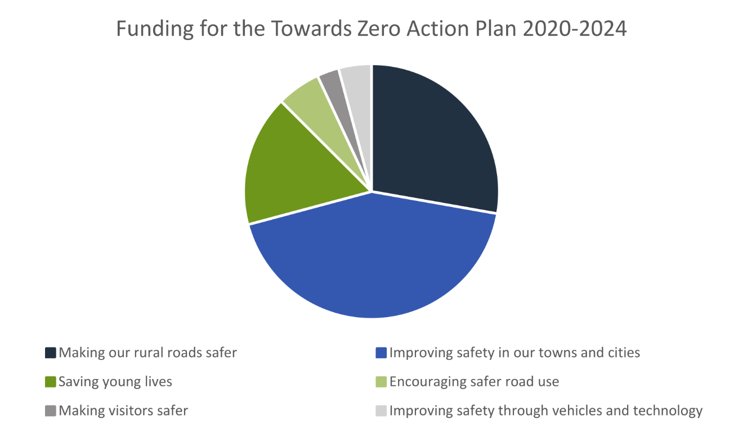

Project status report
Making our rural roads safer
Rural road grants program for local government | On schedule |  | Infrastructure upgrades on low volume State roads | On schedule
Motorcyclist safety on rural roads | On schedule |  | Speed moderation and community engagement strategy | On schedule
Safe system knowledge and skills training | On schedule
Improving safety in our cities and towns
Targeted infrastructure upgrades in high traffic urban areas | Not yet commenced |  | Vulnerable Road User Program | On schedule
Community Road Safety Program | On schedule |  | Trial of innovative technologies | On schedule
Innovative infrastructure treatment demonstrations | Not yet commenced
Saving young lives
Learner Driver Mentor Program and Driver Mentoring Tasmania | On schedule |  | Graduated Licensing System Project for drivers | Complete
Rotary Youth Driver Awareness Program | On schedule |  | Driving for Jobs Program | On schedule
RACT education initiatives | On schedule |  | Real Mates media campaign | On schedule
Bicycle Network bike education | On schedule |  | Safety around schools | On schedule
Kidsafe child restraint check program | On schedule |  | Full Gear motorcycle safety project | On schedule
Develop a Graduated Licensing System for motorcyclists | On schedule |  | RACT Youth Road Safety Program | On schedule
Encouraging safer road use
Inattention and distraction | On schedule |  | Safe behaviour campaigns | On schedule
Mandatory Alcohol Interlock Program | Major delays |  | Protective clothing for motorcyclists | On schedule
Road safety penalties review | On schedule |  | Speed enforcement strategy | On schedule
Enforcement of high-risk behaviours | On schedule |  | Automated Traffic Enforcement Program | On schedule
High-risk motorcycling enforcement | On schedule |  | Road Rules Awareness | On schedule
Making visitors safer
Tourist road safety signage program | Commenced |  | Responsive electronic signage trial | On hold
Tourist education materials | On schedule |  | Strategic partnerships | On hold
Tourist education at gateway entry points | On schedule |  | Stakeholder alliances | On hold
Improving safety through vehicles and technology
ANCAP | On schedule |  | Safer cars for young drivers | Not yet commenced
Autonomous vehicle and crash avoidance readiness | On schedule |  | Workplace driver safety | Not yet commenced
Light vehicle safety strategy | On schedule


Progress on key themes


60 per cent of fatalities occur in rural areas

Rural roads grants program for local government
The Safer Rural Roads Program (SRRP) provides funding to councils to implement infrastructure treatments on rural road corridors to reduce lane departure crashes and the harm when they do occur. The allocation for the SRRP increased from $2 million to $2.5 million under the current Action Plan.
Current situation / comments
The previous Minister for Transport approved a combined pool of funding of $4.5 million to deliver the Vulnerable Road User Program (VRUP) and SRRP for 2025. There was an allocation of $2.5 million in funding for the SRRP and $2 million to the VRUP. Funding was approved as a combined sum to enable funding to be transferred between programs, in the case that one program was undersubscribed and another was oversubscribed.
The 2025 round of the SRRP opened for applications on 17 March 2025 and closed on 16 May 2025. The SRRP received nine submissions. These applications were assessed by the program’s Assessment Committee on 2 June 2025, of which eight were recommended for funding. The eight recommended applications utilised $1.9 million of the $2.5 million in available funding, with the remaining funding used towards the VRUP.
As of 31 December 2025, four projects are in the delivery of works stage, one project is waiting for State Growth Traffic Engineering approval of finalised plans, and three projects are still in the finalising plans stage.
The Road Safety Branch continues to work with councils that have outstanding projects from previous funding rounds.
Status | risk |  | On schedule/progressing/low risk

Infrastructure upgrades on low volume State roads
This program will provide funding for lower volume State roads, where cost effective treatments such as shoulder sealing, pavement markings, curve warnings, roadside hazard removal and safety barriers will achieve maximum value for money.
Current situation / comments
This program of works has supported Road Safety Levy co-contributions under the Australian Government’s RSP. This has taken advantage of the opportunity that Australian Government co-funding has presented for targeted shoulder sealing and junction upgrades across Tasmania.
The projects included under the current stage of the Australian Government’s Road Safety Program (2023-2027) include:
- Sheffield Main Road – Shoulder sealing - $12 million
- Frankford Main Road / Chapel Road – Junction realignment - $1.2 million
- Pipers River Road / Waddles Road – Junction realignment - $1.2 million
- Brooker Highway / Foreshore Road – Signalised intersection - $9.7 million
- Midland Highway / Lake Leake Road – Channelised right turn lane - $3.4 million.
- King Meadows Interchange – exit lane extension - $3.3 million
Furthermore, a pipeline of projects currently exists with projects assessed as having a significant road safety benefit and which occur on parts of the State rural road network that are unlikely to secure funding from other sources. The projects include a range of treatments ranging from realignment to shoulder sealing and channelised right turns.
The RSAC recently endorsed $7.6 million funding from the Road Safety Levy for the following projects:
- a channelised right turn lane at the junction of the Tasman Highway and Brinktop Road
- a realignment on the Frankford Main Road, and
- funding for design work for potential future pipeline projects.
These projects are now with State Growth for development and delivery.
Status |  |  | On schedule/progressing/low risk

Motorcyclist safety on rural roads
Road safety audits will be conducted on high-risk touring routes across Tasmania. This program will involve local motorcyclists and a safe system approach will inform audits. Findings will be shared with stakeholders to identify countermeasures that go beyond typical infrastructure solutions.
Current situation / comments
Safe System motorcycle road safety audits
On 2 and 3 December 2025, an audit of Wilmot Road and Cradle Mountain Road (Forth Road to Cethana Road) was conducted in collaboration with the Central Coast and Kentish Councils. The audit included a group ride of the route with six motorcycle riders from across Tasmania, followed by an interactive workshop. The audit report, including the recommended treatments, is expected to be provided to the Department in early 2026.
Status |  |  | On schedule/progressing/low risk

Speed management and community engagement strategy
Speed management requires a holistic strategy encompassing public education, road risk assessments, enforcement, speed limit setting, infrastructure measures, vehicle technologies, outcomes and evaluation. This project will involve community engagement to inform and build support for action on safer speeds. A significant ongoing coordination effort will be required to support the strategy.
Current situation / comments
Work continues on the development of the Speed Management Strategy. The project has now completed independent expert reviews of the draft Strategy framework, including the aim, principles, and outcomes. Review recommendations are now being considered for inclusion in the draft Strategy. Work has commenced on the development of actions under the five action areas, with the draft package of actions being informed by targeted engagement and feedback in February and March 2026.
The project supplier has also completed speed limit modelling for the Tasmanian road network. This is using the underlying data from the Road Safety Enforcement Allocation Model (RSEAM). A dashboard has been developed to show modelling outcomes and allow for configurable speed limit scenarios. This will inform what FSI savings can broadly be expected from proposed speed limit policies considered under the Strategy. The model is designed primarily to analyse potential speed limit changes across road categories.
Work has commenced on a Community Engagement and Communications Plan that will guide community engagement efforts, partnerships and development of key messages. The Plan will consider the risks, barriers and opportunities that exist in the Tasmanian context, from lessons learned from the real-world implementation of speed management.
Status |  |  | On schedule/progressing/low risk

Safe system knowledge and skills training
This initiative aims to improve Safe System knowledge for all those in a position to influence road safety outcomes. The initiative will focus on Safe System infrastructure design, including appropriate speed setting, and will consist of technical training sessions, workshops and forums across Tasmania.
Current situation / comments
The Department of State Growth continues to support the completion of the Safe System induction module amongst all Transport Group employees and staff across Tasmania Police and local government. The unit provides an introduction to the Safe System.
Status |  |  | On schedule/progressing/low risk


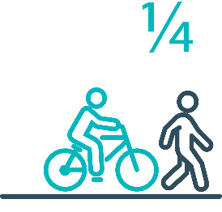
Pedestrians and cyclists are vulnerable and represent one in four serious casualties in our towns and cities

Targeted infrastructure upgrades in high traffic urban areas
This program provides for delivery of a range of infrastructure safety upgrades to make our towns and cities safer. This will include shoulder sealing, intersection improvements, safety barriers and pavement marking at high traffic areas. This program targets high volume state roads that are not planned for major investment in the short term.
Current situation / comments
This initiative has not yet commenced and will be considered as part of the next action plan.
However, funding allocated to this initiative to date, under the Action Plan, has supported the Road Safety Levy co-contributions under the Australian Government’s Road Safety Program (RSP). This has taken advantage of the opportunity that Australian Government co-funding has presented for targeted shoulder sealing and junction upgrades across Tasmania, and the upgrade of nearly 600 electronic school zone signs across approximately 220 locations.
Status |  |  |  | Not yet commenced

Vulnerable Road User Program
The Vulnerable Road User Program (VRUP) is an established grants program which assists local government with the costs of installing safety improvements in built up areas. The aim of the program is to reduce conflict between vehicles and vulnerable road users - cyclists, pedestrians and motorcyclists.
Additionally, the program has a focus on increasing Safe System knowledge and capacity in local governments. The funding available under the VRUP was increased from $1 million to 2 million per annum, under the current Action Plan.
Current situation / comments
The previous Minister for Transport approved a combined pool of funding of $4.5 million to deliver the Vulnerable Road User Program (VRUP) and SRRP for 2025. There was an allocation of $2.5 million in funding for the SRRP and $2 million to the VRUP. Funding was approved as a combined sum to enable funding to be transferred between programs, in the case that one program was undersubscribed and another was oversubscribed.
The 2025 round of the VRUP opened for applications on 17 March 2025 and closed on 16 May 2025. The VRUP received 31 applications. These applications were assessed by the program’s Assessment Committee on 6 June 2025, with 21 projects recommended for funding. These 21 projects utilised $2.5 million in funding. This included the original $2 million allocated, as well as additional funding that was not utilised under the SRRP.
As of 31 December 2025, six of the projects are in the delivery of works stage, four are waiting for State Growth traffic engineering approval of finalised plans and eleven projects are still in the finalising plans stage.
The Road Safety Branch continues to work with councils that have outstanding projects from previous funding rounds.
Status |  |  | On schedule/progressing/low risk

Community Road Safety Grants Program
The Community Road Safety Grants Program (CRSGP) is an established grants program that aims to build community engagement to address local road safety issues. The program supports local councils, schools, community groups, research institutions and charity organisations to promote road safety at the grass roots level.
Current situation / comments
On 5 September 2025, the Minister for Instructure and Transport approved the 2024-2025 funding round of the Community Road Safety Grants Program, allocating $305,884 to 11 successful recipients.
To date, one project has been completed. The Unconformity Inc. received $26,681 for its Unconformity Festival Drive Journey Campaign, a road safety initiative targeting drivers travelling to The Unconformity Festival. The project supported safer driving during a high‑traffic period by promoting alternative transport options and encouraging drivers to rest, slow down, and travel mindfully.
The Road Safety Branch continues to actively support grant recipients to facilitate the effective delivery and implementation of funded projects.
Status |  |  | On schedule/progressing/low risk

Trial of innovative technologies
This project will include monitoring, investigation and trialling of new and emerging technology-based approaches to improving safety for vulnerable road users.
Current situation / comments
The Department of State Growth has agreed to participate in a trial of Motorcycle Perceptual Countermeasures (PCMs) being conducted by the Centre for Automotive Safety Research (CASR), to be largely funded by the Australian Government’s National Road Safety Action Grants (NRSAG) program.
The trial aims to build upon the Austroads report AP-R688-23 Motorcycle Rider Perceptual Countermeasures (April 2023), to undertake further analysis of potential benefits and or risks identified through this study. The Austroads report found that PCM decreased the travel speed of motorcycles at the apex of the treated curves and better positioned the riders in the lane.
In May 2025, Safe System Solutions facilitated a stakeholder workshop to discuss the possible locations and design of treatments that will be included in the trial. Six Tasmanian representatives attended the meeting. CASR are now finalising the design with the treatments expected to be installed in February 2026.
Status |  |  | On schedule/progressing/low risk

Innovative infrastructure treatment demonstrations
This project will investigate, trial and demonstrate innovative Safe System urban infrastructure treatments to improve road safety in our urban areas. We will work with local councils to show how Tasmania’s cities and towns can be improved for the benefit of all road users, particularly cyclists and pedestrians.
Current situation / comments
This project has not yet commenced and will be considered as part of the next Action Plan
Status |  |  |  | Not yet commenced.




92 young people are seriously injured or killed on our roads every year

Learner Driver Mentor Program and Driver Mentoring Tasmania
The Learner Driver Mentor Program (LDMP), supported by Driver Mentoring Tasmania (DMT), is a well-established program that supports disadvantaged learner drivers to gain supervised on-road driving hours to gain a licence. DMT supports LDMP providers through peak body support and coordination.
Current situation / comments
Administration of the 2025–27 LDMP funding round was completed in early July 2025, ensuring continuity of service across all regions of Tasmania. A total of $2.83 million was allocated from the Road Safety Levy to support the delivery of supervised driving opportunities through 16 community-based organisations.
Of this funding, $2.4 million was provided directly to LDMP providers to support program coordination, mentor engagement, and vehicle operating costs. A further $175,000 was set aside for the replacement of up to five program vehicles, ensuring that all LDMP vehicles maintain a minimum 3-Star Used Car Safety Rating (UCSR). $172,559 was provided to Driver Mentoring Tasmania (DMT) for statewide coordination and support functions, and the remaining funds were allocated to mentor recruitment, retention, and training activities.
Between 1 October and 31 December 2025, the LDMP delivered 3,713 hours of supervised on-road driving, supporting learner progression through the Graduated Licensing System. During this period, 52 participants successfully achieved a provisional licence, demonstrating continued program effectiveness despite sustained demand pressures across the state.
During the reporting period, the Statewide Coordinator employed by Driver Mentoring Tasmania resigned. DMT has advised that it intends to advertise for a replacement coordinator role in 2026 to fulfil its remaining contractual obligations under the current funding agreement. The Department will continue to monitor service continuity and support arrangements to ensure that statewide coordination functions are maintained for the duration of the agreement.
Status |  |  | On schedule/progressing/low risk

Graduated Licensing System Project
Changes have been made to the Graduated Licensing System (GLS) for drivers to better protect young and novice drivers and improve the licensing pathway. Young drivers are overrepresented in crash statistics and most at risk when they first get their Ps and start driving solo. The changes to the GLS aim to address this risk and improve road safety outcomes for both young and novice drivers.
Current situation / comments
The Tasmanian Government implemented regulatory changes to the GLS on 1 December 2020. Tasmania’s GLS now meets the enhanced model under the national driver GLS framework. The GLS changes were accompanied by a public education campaign explaining the policy changes and how they would apply to current and new learners.
Complementing the policy changes are three digital products that were progressively launched from July 2021.
The Plates Plus learning and assessment platform was designed to improve learner driver education by focusing on developing safe behaviours and attitudes. It is an innovative tool that takes users through a series of interactive exercises to ensure new drivers know the road rules and understand the impact of the fatal five road behaviours.
A public education campaign accompanied the launch of the Plates Plus platform and ran until September 2021. The campaign encouraged take-up by promoting the convenience of the platform, which is accessible from any device connected to the internet.
The Plates Plus logbook app launched in November 2021. For many Tasmanian learners, this will replace the existing hard copy logbook. It provides an easy and efficient way to record supervised driving hours during the learner licensing phase. A public education campaign targeting 15 to 25-year-olds accompanied the launch of the Plates Plus logbook app. To engage with this age group, the campaign focused on selected social media platforms.
The computer-based hazard perception test (HPT) was launched on 7 March 2022. The HPT is a mandatory assessment that has been introduced to the learner licensing pathway. The HPT assesses a learner’s ability to identify and react to safely avoid hazards. It features high-quality 3D clips developed by Austroads in conjunction with the Centre for Automotive Safety Research, using real Australian crash data to identify the most dangerous driving situations for novice drivers.
The HPT was the final product to be delivered under the GLS project.
State Growth contracted the Queensland University of Technology (QUT) Centre for Accident Research and Road Safety – Queensland (CARRS-Q) to undertake an evaluation of the changes over a seven-year period, including crash and offence-based analyses and personal experiences of Tasmanian residents. The intermediate phase of the evaluation has been completed. The final phase commenced in late 2025. This phase will consider crash involvement, licensing and offence trends, surveys, focus group and stakeholder consultations.
Status | Complete

Motorcyclist Graduated Licensing System review
The Tasmanian motorcyclist GLS is being reviewed to identify enhancements to ensure novice motorcyclists are as safe as possible on Tasmanian roads.
Current situation / comments
Following initial consideration by the Department of State Growth, the Centre for Automotive Safety Research (CASR) was engaged to conduct a review of the Tasmanian motorcyclist GLS. The findings and recommendations of the review were presented to the Road Safety Advisory Council (RSAC) at its May 2022 meeting.
A public consultation process sought feedback on CASR’s recommendations. Feedback was collated and presented to the RSAC at its November 2022 meeting, together with a package of options to amend the motorcyclist GLS. At the RSAC’s request, additional information was provided and considered at its March 2023 meeting. The RSAC endorsed a package of recommended changes to the motorcyclist GLS which the former Minister for Infrastructure and Transport approved. Consideration of the package by the Tasmanian Government was delayed due to the caretaker and election periods and formation of a new Government. In October 2024, the Minister for Transport approved a package of changes to the motorcyclist GLS. Implementation is in progress, with regulatory amendments being prepared.
Status |  |  | On schedule/progressing/low risk

RYDA program
RYDA is a one-day interactive road safety education program for Year 10-12 students to assist them to respond positively to the challenges and responsibilities of being a driver or passenger. RYDA’s curriculum consists of six sessions, each focusing on critical aspects of road safety, including speed management, distraction avoidance, and the importance of responsible driving. Professional facilitators, including Tasmania Police and experts from road safety organisations, lead the sessions. Rotary volunteers support the program's operations, handling logistics, coordination with schools, and ensuring smooth delivery across six statewide locations.
RYDA has proven to be a transformative experience for students, fostering attitudinal changes towards driving. The program encourages young drivers to think critically about their behaviour on the road, equipping them with the knowledge and skills needed to make safer choices. Additionally, students who participate in RYDA receive a five-hour reduction in the mandatory driving hours required for their learner’s licence, further incentivising participation.
Current situation / comments
In December 2025, RYDA was delivered at Smithton High School. The program remains ongoing, with the Road Safety Branch continuing to work closely with Rotary Tasmania to support effective program implementation.
RYDA facilitators remain committed to ensuring all Year 10 students across Tasmania have the opportunity to participate in the program, prioritising school visits based on need and accessibility.
Status |  |  | On schedule/progressing/low risk

Driving for Jobs Program
The Driving for Jobs (DfJ) Program aims to support disadvantaged students who would otherwise be unable to enter and progress through the Graduated Driver Licensing System (GLS). The program provides students at selected schools with the opportunity to increase their road safety knowledge whilst also improving their job readiness. Students undertake a personalised intensive program with a strong road safety focus including professional on-road driving lessons and participation in the Rotary Youth Driver Awareness Program (RYDA).
Current situation / comments
For the 2025 year, DFJ supported 264 students, with 76 obtaining their learners licence and 62 obtaining their provisional licence.
Between 19 October and 18 December (Term 4). 371.5 hours of driving lessons were provided through the Driving for Jobs.
Status |  |  | On schedule/progressing/low risk

RACT education initiatives
The RACT delivers a range of community and school-based road safety education programs for seniors, community groups and primary and secondary students.
Current situation / comments
RACT has been awarded $105,779 for the 2025-2026 financial year, to deliver its suite of road safety education programs. As outlined in their Grant Deed, RACT will deliver:
- 18 ‘Years Ahead’ presentations to elderly community groups
- 6 ‘Dangers of Distractions’ sessions for high school students, and
- 40 ‘RoadSafe’ presentations targeting primary school students.
These initiatives complement broader road safety efforts by engaging key age groups with tailored education to promote safer behaviours across the lifespan.
RACT’s education initiatives remains underway, supported through ongoing coordination with the Road Safety Branch.
Status |  |  | On schedule/progressing/low risk

Real Mates media campaign
The MAIB-funded Real Mates campaign engages with young men to encourage them to avoid the risks of drink driving by empowering them to speak up and stop a mate from driving after drinking.
Current situation / comments
The current Real Mates campaign, the Bro Code, focuses on planning ahead and making sure mates get home safely after a night out. The rules, unwritten social codes among male friends, have been updated to include practical safety measures such as making a plan to get home, offering a place to stay, having a designated driver, covering taxi or Uber costs, calling a parent for a lift, and never leaving a friend behind. In this context, a “bro” can be anyone who looks out for you, whether a friend, sibling or parent.
The campaign targets males aged 17 to 25, who account for around a quarter of all alcohol-related crashes in Tasmania in the past five years. With fewer transport options in rural and regional areas, the importance of planning ahead is a key message.
Recent bursts have coincided with the AFL Grand Final weekend, and another is scheduled for the Christmas and New Year period, a time of increased social activity and celebrations when alcohol-related risks are higher. Messaging will continue to run predominantly on social media, supported by television and radio. It will also feature through on-ground activations at venues and events, including Hobart Hurricanes and JackJumpers home games. Supporting merchandise has been distributed statewide through the Tasmanian Hospitality Association and Clubs Tasmania.
Status |  |  | On schedule/progressing/low risk

Bicycle Network bike education
The Bicycle Network delivers the Ride2School program designed to promote safe cycling habits, road safety awareness, and positive road-sharing behaviour among primary-aged students. Through engaging educational sessions, the program encourages young students to embrace cycling as a safe and sustainable mode of transport.
Current situation / comments
The Bicycle Network has been awarded $95,201 to deliver the Ride2School program for the 2025-2026 financial year. As outlined in their Grant Deed, they will deliver a minimum of:
- 110 bicycle safety workshops (40-90 minutes duration), and
- 2 ActiveMaps across Tasmanian Primary School.
The Bicycle Network will strive to reach these targets through the continuation of the program within the network of schools currently engaged in Ride2School, expanding into new schools, refining program initiatives, and strengthening recently established partnerships.
Delivery of the Ride2School Program is progressing, with sustained partnership between the Bicycle Network and the Road Safety Branch.
Status |  |  | On schedule/progressing/low risk

Safety around schools
Safety around schools is promoted through designated crossings, lower speed zones, more than 100 school crossing patrol officers and public education. The current Safety around Schools project, including the Love 40 campaign, encourages drivers to lower their speed and keep a look out for children in school zones and around buses.
Current situation / comments
The Safety Around Schools campaign is an ongoing initiative that is conducted at the commencement of each school term. In 2025, the Love 40 campaign was revitalised with a new theme titled ‘Grow Up, There’s No Excuse in a School Zone.’ This campaign features children dressed and acting like adults, delivering familiar excuses that drivers often give for not adhering to school zone rules.
Status |  |  | On schedule/progressing/low risk

Kidsafe child restraint check program
Kidsafe Tasmania conducts free child restraint checking and training sessions for professionals to ensure young children are safely and lawfully seated and restrained in cars. Kidsafe also distribute and promote educational materials to inform the public of the correct child restraint type for a child’s age and size.
Current situation / comments
Kidsafe Tasmania has been awarded $52,890 for the 2025-2026 financial year to deliver is Child Restraint Check Program. As outlined in their Grant Deed, Kidsafe Tasmania will:
- develop and disseminate key educational resources (both print and digital) in consultation with stakeholders
- conduct eight training sessions for community organisations on correct child restraint installation, and
- deliver 20 child restraint check sessions across community settings.
This initiative aims to build community capacity and enhance child passenger safety outcomes across Tasmania.
Kidsafe Tasmania is continuing to deliver the child restraint check program, with active engagement and support from the Road Safety Branch.
Status |  |  | On schedule/progressing/low risk

Full Gear motorcycle safety project
The Glenorchy City Council, in partnership with Bucaan House, delivers its successful Full Gear motorcycle safety project (Full Gear), which helps at-risk young motorcycle riders to enter the licensing system and adopt safe riding practices.
Current situation / comments
Glenorchy City Council has been awarded $56,618 for the 2025-2026 financial year to deliver the Full Gear Motorcycle Safety program. As outlined in their Grant Deed, the program includes:
- An eight-week road safety program, including a pre-learner motorcycle course for participants who complete the program.
- One small community campaign and public presentations developed by participants in each program cycle.
- One large community campaign developed by participants in all programs for the year.
The Full Gear Motorcycle Safety program aims to promote safer riding practices and strengthen community engagement around motorcycle safety.
The Full Gear program continues to operate as planned, with the Road Safety Branch providing ongoing support to Glenorchy City Council in its implementation.
Status |  |  | On schedule/progressing/low risk

RACT Youth Road Safety Program
The Youth Road Safety program is a five-year comprehensive road safety education program funded through an $8 million election commitment. This initiative aims to drive down rates of serious injury and death among young drivers, who are overrepresented in our road trauma statistics.
Current situation / comments
Building on the discovery and early design work completed last quarter, the RACT Youth Road Safety Program has progressed into its next phase, focused on strengthening collaboration with key stakeholders, applying evidence and lived experience to refine understanding, and developing initial concept ideas to inform subsequent design, testing and implementation planning.
The following activities have been completed this quarter.
Consultation / Research
- Delivered a co-design workshop with parents and young drivers, generating insights into learner-supervisor dynamics and needs and informing concept development.
- Youth consultations were conducted in collaboration with the Youth Network of Tasmania (YNOT), with young people providing valuable insights into learner experiences, supervisor challenges and road safety. Further workshops are planned, including with advertising agency The20, to help establish a youth-led brand for the project.
- Worked alongside State Growth to refine and source data to support the Journey Map, incorporating licensing milestones and offence data to illustrate the licensing journey. This work is informing us about gaps, issues and opportunities.
- The project, through Nerida Plumpton, Project Manager, is engaged in the FIA Safe Mobility for All and 4 Life training program (SM4A4L). This is an FIA funded Road Safety capability building partnership between FIA and United Nations Institute of Training and Research (UNITAR). Involvement is the result of a successful application process supported by State Growth. It is made up of a group of approximately 12 people across Asia Pacific clubs and involves online training in best practice road safety, some in person forums, and project mentorship from an international expert yet to be assigned.
Grant Deed
- Completed Acquittal for initial Grant Deed with approval to carry forward unspent funds to the next 4-year Grant Deed.
- Liaised with State Growth and proposed draft terms for next 4-year Grant Deed. Currently with State Growth for finalisation.
Updates on Focus Areas
Focus Area 1 – Education
- Recruitment process for a 1-year Education Specialist role underway with support from the Department of Education, Children and Young People (DECYP), Catholic Education and Independent Schools.
Focus Area 2 - Parent / Driver Supervisor
- Successful co-design workshops in late November leading to future concepts that will be refined and tested with community including regional areas
Focus Area 3 – Community / Disadvantage
- Social Return on Investment study being conducted by Social Ventures Australia SVA) of 3 learner driver support programs (Driving for Jobs, Learner Driver Mentor Program, and YFCC) is well underway. Minor delay with data collection with LDMP but hoping to catch up. Expected to be completed by June 2026.
Status |  |  | On schedule/progressing/low risk


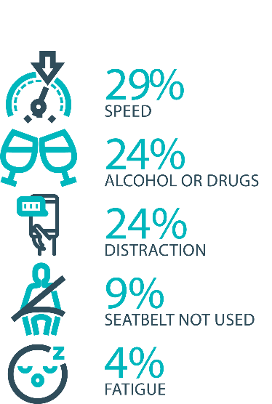

The fatal five behaviours contributing to serious casualties

Inattention and distraction
Inattention and distraction are concerning causes of serious casualty crashes and may have a far greater impact than current data suggests. There are a number of research projects and enforcement initiatives that are being used to address this issue. This project will include consideration of emerging strategies for tackling distraction, encouraging compliance through enforcement and influencing driver behaviour through public education campaigns.
Current situation / comments
Enforcement
A continuing upward trend in fatal crashes has occurred over the current reporting period, with 42 road deaths for the 2025 calendar YTD (at 16/12/25). This compares with 26 over the same period in 2024. The 42 fatalities are partially comprised of nine motorcyclists and two pillion passengers, seven interstate/overseas drivers and five pedestrians. This total (23) accounts for 54.7 per cent of all fatal crashes. Of the total 259 fatal and serious crashes, 51 (19.7per cent) are attributed to inattention, 35 (13.5 per cent) involve excessive speed and 34 (13 per cent) involve alcohol and/or drugs.
After a notable improvement in road policing outputs by Tasmania Police during the 2024-25 financial year, it is pleasing from an output perspective, to note an additional 6.3 per cent of detections over and above the preceding reporting period. This equates to a further 1135 interdictions/prosecutions – statistics that reflect positively upon a ‘whole of agency’ approach to road policing.
Mobile District Traffic Operations remain static, having previously increased by 40.7 per cent in 2024-25 compared to 2023-24. Major Static District Traffic Operations having increased by a significant 38.5 per cent, having already increased by 34.1 per cent during the previous financial year.

Public Education
The We’re Looking Out for You road safety campaign has run over public holidays and other holiday periods. The campaign focuses on encouraging drivers to reflect on their behaviour during the holiday period, emphasising the importance of getting home safety. With the tagline ‘We're looking out for you this holiday season.’ it highlights that getting caught breaking road rules could actually save lives, helping to prevent a catastrophic crash before it occurs.
Status |  |  | On schedule/progressing/low risk

Safe behaviour campaigns
Targeted media campaigns will continue to educate people about high-risk behaviours and to highlight the dangers of the ‘Fatal Five’.
Current situation / comments
In July Different day, different drive, was launched, reminding Tasmanians that driving to the conditions can be the difference between a safe arrival and a serious crash. The campaign highlights Tasmania’s constantly changing road environment – from wet or icy surfaces and sun glare to wildlife and heavy traffic – and the need for drivers to adapt their behaviour accordingly.
The message is particularly important given Tasmania’s ongoing challenge with road trauma. Speed is a major contributor, not just when people exceed the speed limit, but when they drive too fast for the conditions. Research shows that “excessive speed for the conditions” is a factor in a significant proportion of fatal and serious injury crashes.
The campaign has been run in winter months across television, radio, billboards and bus backs, aiming to make adaptive driving second nature for Tasmanians. By encouraging drivers to slow down, increase following distances and anticipate hazards, the campaign supports our broader effort to reduce trauma and ensure more people make it home safely.
The Over is Over campaign challenges the misconception that driving just a few kilometres over the speed limit is acceptable. It draws on Tasmania’s history of adopting other life-saving measures – like seatbelts, reduced blood alcohol limits, random breath testing and mobile phone restrictions – which were once resisted but are now widely accepted.
The campaign continues to run across television, radio, billboards, bus backs and social media, with another burst scheduled for early 2026. Its aim is to shift community attitudes towards speeding in the same way past reforms have reshaped safe driving behaviours.
A new Love40 campaign was launched in February this year in line with schools returning for 2025. Titled ‘There’s No Excuse in a School Zone’, the campaign features children dressed and acting like adults, delivering familiar excuses that drivers often give for not following the rules in a school zone. The new campaign features on television, radio and digital media platforms. It continues to run throughout the year in an always on schedule.
The ‘You Can’t Beat Tassie Roads’ motorcycle campaign and the cycling safety campaign have run at various intervals throughout the yar with another burst scheduled over the summer/daylight savings period. The motorcycle campaign serves as a reminder for touring motorcyclists, both local and from interstate or overseas, to drive carefully on Tasmanian roads. The purpose of this cycling safety campaign is to promote mutual respect and safety between cyclists and motorists on shared roads. It emphasises that everyone is accountable for their actions, regardless of their mode of transportation, and encourages road users to support one another to ensure everyone's safe return to their loved ones.
The ‘Driving Tired? Wake Up to Yourself’ fatigue campaign ran earlier this year and another burst, featuring new assets, will be run across TV, online, radio and social media platforms later this year and early next year. Launched in Tasmania in November last year, the campaign is centred around a powerful television advertisement that highlights the devastating consequences of driving while fatigued.
Fatigue remains a significant concern on Tasmanian roads, with research showing that 15 to 20 per cent of serious and fatal crashes involve inattention, distraction or poor decision-making - all common signs of fatigue. Backed by research from Monash University and the Victorian Transport Accident Commission, the campaign continues to raise awareness that fatigue can affect anyone, even on short trips or close to home, reinforcing the importance of getting adequate sleep before driving.
Status |  |  | On schedule/progressing/low risk

Mandatory Alcohol Interlock Program (MAIP)
The MAIP aims to have repeat and high-level drink driving offenders demonstrate they are able to separate their drinking from driving through the installation of an alcohol interlock in their vehicle. New measures will be introduced to increase participation in the MAIP.
Current situation / comments
Drafting instructions for the revised framework were provided to the Office of Parliamentary Counsel (OPC) in October 2019. Parliamentary priorities, including COIVD-19, caused reprioritisation of OPC work. Drafting instructions were withdrawn from OPC in May 2021, before the first draft of amendments had been received, to enable the new Road User Services’ managers to review the drafting instructions to ensure that they remain current. The revised instructions were re-submitted to OPC on 15 February 2022. Again, Parliamentary priorities slowed the work of OPC. Nonetheless, version 2 of the amendments was received in November 2022. Drafting work has been suspended pending a review to determine whether the proposed amendments will create a best practice program. Road Safety Branch commenced the review in late 2024. A review of the MAIP will be considered under the next Road Safety Strategy which is currently being developed. The drafting instructions are to be revised to accommodate the Government’s stated desire for an efficient legislative corpus.
Status | Major delays/on hold/high risk

Protective clothing for motorcyclists
Motorcyclists are overrepresented in Tasmania’s road trauma figures. Motorcyclists are vulnerable road users due to a lack of physical protection. Protective clothing can reduce injury severity in the event of a crash. Tasmania is a funding member of MotoCAP. MotoCAP provides safety assessment star ratings for protective clothing and prepares education materials for motorcyclists.
Current situation / comments
For the 2025 calendar year, a brochure educating riders on the importance of wearing protective motorcycle gear has been included in all motorcycle licence renewal papers. The brochure reiterates the importance of wearing full gear on every ride and directs motorcyclists to the MotoCAP website to check gear safety ratings before purchase.
Status |  |  | On schedule/progressing/low risk

Road safety penalties review
For enforcement activities to improve safety on our roads, they need to be backed up with appropriate penalties. Tasmania’s road safety penalties will be reviewed to ensure they are up-to-date and provide an appropriate deterrence to those who break the rules and put themselves and others at risk.
Current situation / comments
The Department previously completed a review of road safety penalties in 2020, which showed that Tasmania was largely consistent with other jurisdictions, except for speeding offence penalties, which were lower.
The results of that review were presented to the RSAC in November 2020. RSAC recommended not amending penalty values due to the economic impacts of COVID-19 and general parity with other jurisdictions.
Since November 2020, some jurisdictions have implemented higher penalties, which has widened the gap between Tasmania’s penalties and some jurisdictional averages.
The Road Safety Branch (RSB) undertook a review of Tasmanian road safety penalties to compare Tasmanian penalties to the average of other Australian jurisdictions for the fatal five road offences – speed, mobile phones, alcohol and drugs and failure to wear a seatbelt.
The review compared Tasmania’s penalty levels to a ‘jurisdictional average’ (i.e., an average of all other jurisdictions, without inclusion of Tasmania’s penalties) to avoid skewing the average. To ensure that the comparison of monetary penalties considers the differences in earning potential across the jurisdictions, comparisons are being done as a percentage of each jurisdiction’s seasonally adjusted average weekly wage (not a whole dollar value).
A recommendation to consider endorsing amendments to the monetary penalties for offences relating to illegal mobile phone use, seatbelt non-compliance, registration, and speed, was provided to RSAC for review in its May 2023 meeting. RSAC considered the proposal, recommending penalties should not be amended until the effects of the new automatic traffic enforcement program have been considered. RSAC agreed to review penalties again when the evaluation is complete.
Status |  |  | On schedule/progressing/low risk

Speed enforcement strategy
As one of the primary ‘fatal five’ contributory factors, speeding is directly addressed within the Tasmania Police Safe Roads Strategy 2024-2026.
The Strategy directs enhanced speed enforcement strategies and techniques to increase the rate of detection and increase the perception that offending drivers and riders will be caught, through the coordination of high-visibility speed enforcement in high-risk areas across all police districts. To this end, Tasmania Police has detected 11,281 speeding offenders for the 2025-26 financial year to date, compared with 10,512 for the comparable 2024-25 period.
Specific to ‘hooning’ legislation, Tasmania Police has also invested in significant new stores of ‘wheel clamp’ devices. The application of wheel clamps forms part of a wider effort to target speeding, disqualified driving, reckless and dangerous driving behaviours.
Status |  |  | On schedule/progressing/low risk

Enforcement of high-risk behaviours
To reduce high-risk behaviours and increase compliant road user behaviour, State Growth and Tasmania Police will work collaboratively to investigate and introduce new enforcement techniques and technologies to detect high-risk behaviours that address the ‘fatal five’, including mobile phone use, speeding and failure to wear a seatbelt.
Current situation / comments
The Tasmania Police Safe Roads Strategy 2024-2026 directs the activities of all police on the fatal five causes of serious and fatal crashes, which are the highest risk driver behaviours. Of note, drink driving offences are down by 13.8 per cent, while drug driving shows a modest increase of 2.7 per cent in terms of prosecutions. Approximately 255 drink or drug driving tests are awaiting analysis (at 16/12/25).
The 2025-26 financial YTD has already seen Tasmania Police prosecute 8,920 ‘high risk traffic offenders’ – a 3.2 per cent increase on the previous reporting period. Noting the number of serious/fatal crashes that historically occur in rural/regional areas, it is also pleasing to note a 27.6 per cent reduction in such crashes (42) over the 2025-26 FYTD, compared to the preceding period (58). An 11.3 per cent increase in infringements issued within rural/country areas may have contributed positively to these results.
Status |  |  | On schedule/progressing/low risk

Automated Traffic Enforcement Program
Automated Traffic Enforcement (ATE) (ie. speed cameras) is relatively underutilised as a deterrence and enforcement mechanism in Tasmania. This project investigates proven and emerging camera technologies for use at high-risk locations and across the entire road network.
Current situation / comments
For the period 1 July 2025 to 31 December 2025 the ATE Program:
- delivered 13,468 mobile speed enforcement hours, monitored 7,676,770 vehicles, and detected 31,062 offences
- delivered 14,256 fixed speed enforcement hours, monitored 30,770,082 vehicles, and detected 18,587 offences
- delivered 3,385 mobile seatbelt and portable device enforcement hours, monitored 1,298,502 vehicles, and detected 1,692 seatbelt offences and 532 portable device offences, and
- delivered 6,523 mobile registration enforcement hours, monitored 2,853,797 vehicles, and detected 3,185 offences.
During this period, the Department of State Growth also reviewed the ATE Program’s Design and worked closely with Monash University Accident Research Centre (MUARC) to complete an external evaluation of mobile speed camera activities between 1 October 2022 and 31 December 2024.
Status |  |  | On schedule/progressing/low risk

High-risk motorcycling enforcement
Speed is a factor in at least a quarter of motorcyclist serious casualties. Speed cameras offer no deterrence to motorcyclists, whose numberplates are mounted only on the back. Introduction of rear-facing speed cameras will improve detection and deterrence of speeding. This is being considered as part of the Automated Traffic Enforcement Program.
Current situation / comments
The Tasmania Police Safe Roads Strategy 2024-2026 approaches the enforcement of high-risk motorcycle behaviours from several angles. Tasmania Police has:
- worked with the Department of State Growth to re-introduce Automated Mobile Speed Enforcement Cameras that have both a rearward and forward-facing capability to better target and detect high-risk motorcycle behaviour
- introduced an online public portal for members of the public to upload footage relating to traffic offences they have witnessed. Tasmania Police reviews these submissions and allocate prima facie offences to an officer for investigation and follow-up, and
- published the Tasmania Police Safe Roads Strategy 2024 – 2026 which provides for increased patrol hours on rural roads, including many of the popular motorcycle touring routes. The increased patrol hours will be conducted in a mix of covert and overt patrols that will discourage and detect high-risk motorcycle behaviours increasing the perception amongst riders they will be caught anywhere at any time.
Status |  |  | On schedule/progressing/low risk

Road Rules Awareness
Compliance with Road Rules makes our behaviour on the roads predictable, improving safety for all road users. This initiative will ensure that user-friendly and tailored information resources are developed so that the Road Rules are easily understood and adhered to by all road users.
Current situation / comments
The Tasmanian Road Rules Handbook and the Misunderstood Road Rules series of pamphlets are distributed to Service Tasmania locations when required.
Status | Major delays/on hold/high risk |  | On schedule/progressing/low risk





11 per cent of all serious casualties on our roads are non-Tasmanian residents

Tourist road safety signage program
This program will see the installation of tourist signage strategically placed across the road network. The signs will provide important road safety information, relevant to the area road users are travelling in. This program will be undertaken in collaboration with stakeholders, local government and State Roads.
Current situation / comments
This program has commenced. A review of road safety signage around the State is being undertaken to identify opportunities for updated road safety messaging.
Status |  |  | On schedule/progressing/low risk

Responsive electronic signage trial
This project will trial a responsive electronic sign with real time information at regional tourism gateways.
Current situation / comments
This project is currently on hold.
Status | On hold

Tourist education materials
A range of education materials developed using images, symbols and multi-lingual material delivered to specific audiences through targeted communications channels. This includes vehicle hangers, brochures, posters, roadside signs, editorial content, film and digital content.
Current situation / comments
Communications materials are being distributed upon request from stakeholders.
Status |  |  | On schedule/progressing/low risk

Strategic partnerships
Developing strategic partnerships based on synergies with target audiences will enable the effective promotion of road safety messages and education.
Current situation / comments
This project is currently on hold.
Status | On hold

Tourist education at gateway entry points
As an island state, we have the opportunity to strategically place messaging at our gateway airports and seaports to reach visitors with important road safety messaging prior to them driving in Tasmania. This includes a range of educational materials, electronic and static signs and billboards.
Current situation / comments
Printed collateral is in stock and digital billboards display road safety messaging at gateway locations.
Status |  |  | On schedule/progressing/low risk

Stakeholder alliances
Sharing information and collaborating to develop effective strategies and tools to address road safety issues is vital. This project will develop formal and informal stakeholder alliances to encourage input and create opportunities to deliver joint initiatives.
Current situation / comments
This activity is currently on hold.
Status | On hold




The rate of fatal crashes is four times higher for vehicles 15+ years old than for vehicles made in the last five years

Australasian New Car Assessment Program (ANCAP)
Tasmania is a funding member of ANCAP. ANCAP plays a vital role in informing consumers about safety performance of new vehicles and advocates for improved vehicle safety design and specification through public education campaigns, advocacy activities and engagement with governments, corporate fleets, the media and consumers. Activities related to ANCAP will include promotion of safer vehicles and options for an annual vehicle fleet report.
Current situation / comments
Tasmania continues to provide funding support to ANCAP. ANCAP has developed a Strategic Plan for 2023-2030. Tasmania has increased its support of ANCAP with funding of up to $90,000 per annum from the Road Safety Levy. All vehicles rated by ANCAP are evaluated against four key areas of assessment which focus on the protection of vehicle occupants, those outside the vehicle, and the ability of a vehicle to actively avoid a crash.
Status |  |  | On schedule/progressing/low risk

Safer cars for young drivers
This project aims to increase awareness of the Used Car Safety Rating database amongst first time car buyers. This could be promoted through education materials and campaigns and may be able to integrate with the GLS online learning platform.
Current situation / comments
This project has not yet commenced and will be considered as part of the Light Vehicle Safety Strategy.
Status |  |  |  | Not yet commenced

Autonomous vehicle and crash avoidance readiness
This project involves the monitoring and development of safety and autonomous vehicle technologies.
Current situation / comments
A regulatory framework for the use of autonomous vehicles is being considered at a national level and Tasmania is participating in that process. Tasmania is also participating in national work programs to better understand the safety and education implications of developments in Advanced Driver Assistance Systems.
Status |  |  | On schedule/progressing/low risk

Workplace driver safety
Vehicle use in road traffic is the most significant contributor to work-related traumatic injury. This project will aim to promote and encourage employers to adopt safe driving policies based on the WorkSafe, ‘Vehicles as a workplace’ guide.
Current situation / comments
This project has not yet commenced and will be considered as part of the next Action Plan.
Status |  |  |  | Not yet commenced.

Light vehicle safety strategy
A light vehicle safety strategy will be developed to provide public education and undertake enforcement activities to enhance the safety standard of Tasmania’s vehicle fleet.
Current situation / comments
A draft light vehicle safety strategy is being developed. The draft strategy aims to accelerate an increase in the number of newer and safer vehicles and removal of older cars from the light vehicle fleet while increasing the safety of the current vehicle fleet. The draft strategy will be considered as part of the next Action Plan.
Status |  |  | On schedule/progressing/low risk

Funding
Road Safety Levy Overview for the Financial Year 2025/26
As at 31 December 2025 (Quarter 2)
Road Safety Levy Opening Summary
Opening Balance as at 01 July 2025 |  |  | $31,360,629
Annual Allocation to Road Safety Operations |  |  | $ -
Revenue Summary
 |  | Forecast (FY26)  $ | Actual (YTD)  $
Motor Accident Insurance Board Funding |  | 1,560,908 | 881,442
Revenue Inflows from Registrations |  | 18,702,032 | 10,170,187
Funds Available for Distribution |  | 51,623,569 | 42,412,258
Expenditure Summary
Theme no. | Theme | Budget  (FY26)  $ | Actual (YTD)  $
1 | Making our Rural Roads Safer | 6,935,719 | 5,135,667
2 | Improving Safety in our Towns and Cities | 6,675,873 | 1,490,893
3 | Saving Young Lives | 3,159,399 | 2,286,986
4 | Encouraging Safer Road Use* | 8,221,305 | 3,057,133
5 | Making Visitors Safer | 190,000 | 33,014
6 | Improving Safety Through Vehicles and Technology | 201,417 | 101,417
7 | General Support | 402,441 | 326,748
Budget and Expenditure by Category |  | Forecast  (FY26)  $ | Actual (YTD)  $
Infrastructure Expenditure |  | 12,117,886 | 5,919,954
Policy & Projects Expenditure* |  | 13,666,669 | 6,511,905
Total Expenditure |  | 25,784,555 | 12,431,859
Balance as of 31 December 2025 |  | 29,380275 | 29,980,399
Forecast Closing Balance of FY26 |  | 25,839,014
*includes MAIB expenditure
MAIB Funding
As at 31 December 2025

2025/26 Financial Year | Budget  $ | Actual (ytd)  $ | Balance  $
Expenditure (State Growth)
Administration & Public Relations | 300,633 | 146,105 | 154,528
Public Education | 1,260,516 | 720,087 | 540,429
Research | 70,000 | 15,250 | 54,750
Subtotal | 1,631,149 | 881,442 | 749,707
Expenditure (Tasmania Police)
Salaries | 2,424,163 | 1,302,522 | 1,121,641
Operating Expenses | 207,500 | 106,562 | 100,938
Equipment | 589,220 | 156,143 | 433,077
Subtotal | 3,220,883 | 1,565,227 | 1,655,656
Total

 | Department of State Growth  Road Safety Branch  Towards Zero Action Plan 2020-2024  GPO Box 536  Hobart TAS 7001 Australia
 | Phone: | 6166 3243
 | Email: | rsac@stategrowth.tas.gov.au
 | Web: | www.rsac.tas.gov.au
 | © State of Tasmania December 2025

