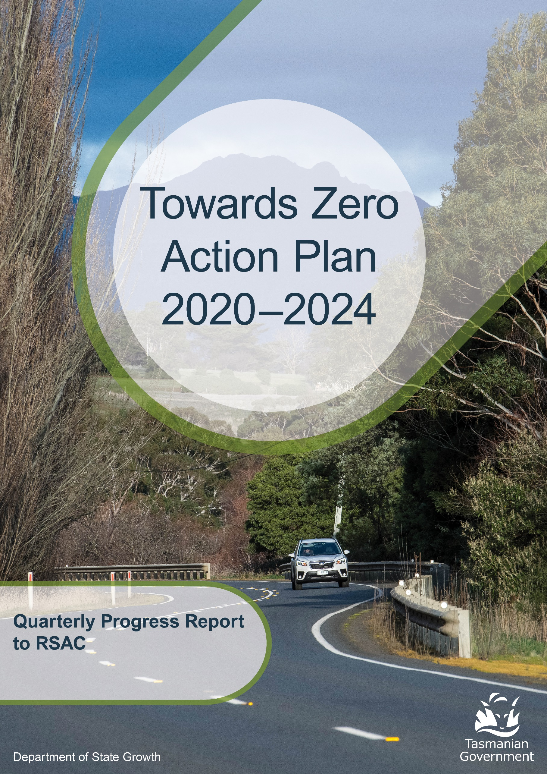

to 30 June 2026

Progress on meeting Towards Zero Strategy targets
The key interim target for the Towards Zero – Tasmanian Road Safety Strategy 2017-2026 (Towards Zero Strategy) is to reduce the number of annual serious injuries and deaths on Tasmanian roads to fewer than 200 by 2026. This is an ambitious target of 100 fewer serious casualties per year than for the period 2012-2016 (annual average) and will move us towards the long-term goal of zero serious casualties on Tasmanian roads.

Serious casualties
The number of serious casualties in 2025 was 324, compared to 337 in 2024, a 3.9 per cent decrease. The 2025 figure of 324 is a 0.6 per cent increase on the five year serious casualty average of 322.2 (2020-2024).

Fatalities
In 2025, there were 43 fatalities on Tasmanian roads which is 14 more than the number recorded in 2024. The figure of 43 fatalities in 2025 is a 14.4 per cent increase on the five-year fatality average of 37.6 (2020-2024).

2026 YTD
There have been 157 serious casualties (17 fatalities and 140 serious injuries) to 30 June 2026, 34 fewer than the number recorded at the same time in 2025 (25 fatalities and 162 serious injuries) and a decrease of 8 per cent on the five year average of 170.8 serious casualties.

Statistics as @ 30 June 2026
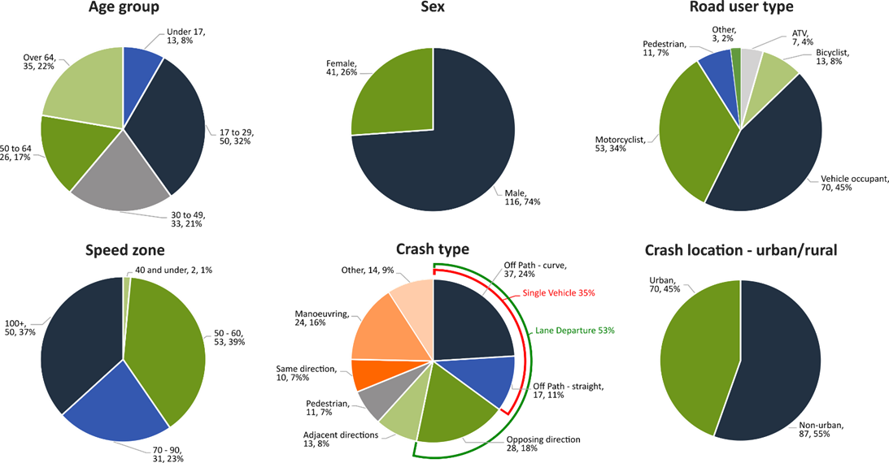

Serious casualty locations as @ 30 June 2026

(Black = Fatality, Red = Serious Injury)
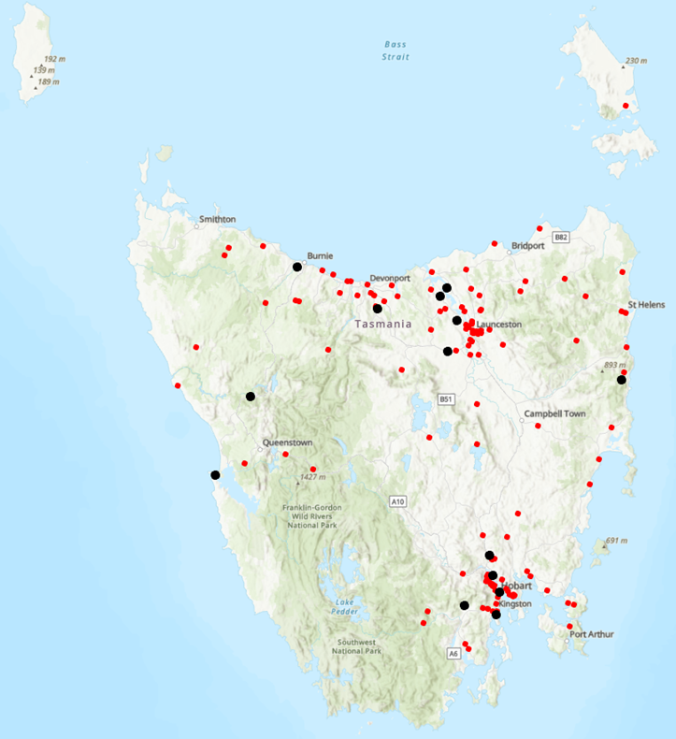

Annual Australian fatalities – Rate per 100,000 population
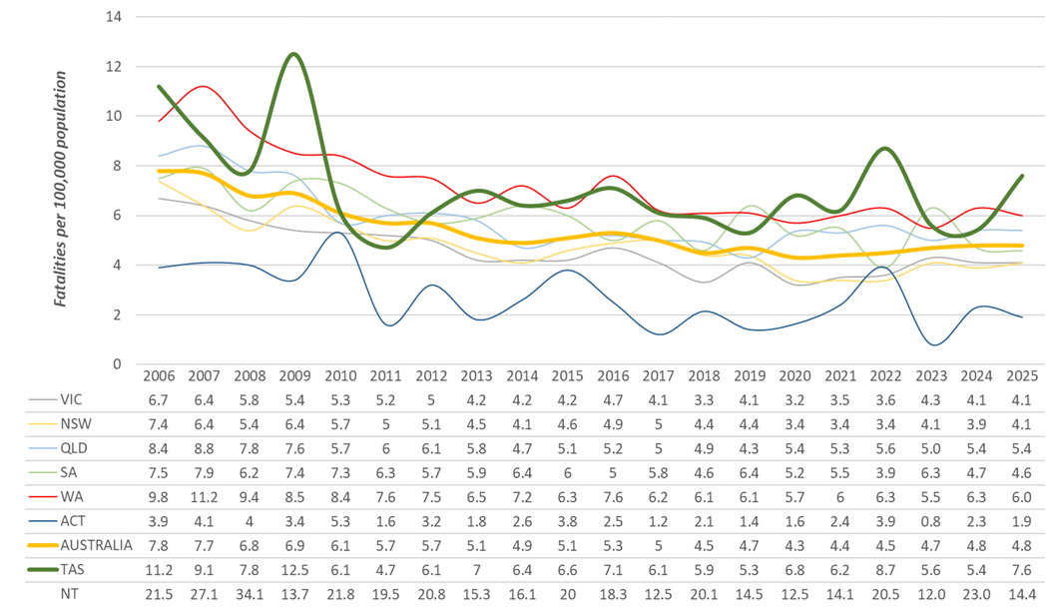

Note: NT omitted from chart for clarity purposes.
Key themes and priority actions – status report
The Quarterly Progress Report details progress on key themes and priority actions under the Towards Zero Action Plan 2020-2024 and the Towards Zero – Tasmanian Road Safety Strategy 2017-2026.
The progress report should be read in conjunction with the Action Plan and understood in the context of the Towards Zero Strategy. These documents and a project description fact sheet are available at: www.rsac.tas.gov.au

Making our rural roads safer
Rural road grants program for local government | Ongoing program |  | Infrastructure upgrades on low volume State roads | Ongoing program
Motorcyclist safety on rural roads | Ongoing program |  | Speed moderation and community engagement strategy | On schedule
Safe system knowledge and skills training | Ongoing program

Improving safety in our city and towns
Targeted infrastructure upgrades in high traffic urban areas | Not yet commenced |  | Vulnerable Road User Program | Ongoing program
Community Road Safety Program | Ongoing program |  | Trial of innovative technologies | Not yet commenced
Innovative infrastructure treatment demonstrations | On schedule

Saving young lives
Learner Driver Mentor Program and Driver Mentoring Tasmania | Ongoing program |  | Graduated Licensing System Project for drivers | Completed project. Ongoing program
Rotary Youth Driver Awareness Program | Ongoing program |  | Driving for Jobs Program | Ongoing program
RACT education initiatives | Ongoing program |  | Real Mates media campaign | Ongoing education program
Bicycle Network bike education | Ongoing program |  | Safety around schools | Ongoing program
Kidsafe child restraint check program | Ongoing program |  | Full Gear motorcycle safety project | Ongoing program
Develop a Graduated Licensing System for motorcyclists | Delayed |  | RACT Youth Road Safety Program | On schedule

Encouraging safer road use
Inattention and distraction | Ongoing program |  | Safe behaviour campaigns | Ongoing education program
Mandatory Alcohol Interlock Program | On hold |  | Protective clothing for motorcyclists | Ongoing education program
Road safety penalties review | On schedule |  | Speed enforcement strategy | Ongoing program
Enforcement of high-risk behaviours | Ongoing program |  | Automated Traffic Enforcement Program | Ongoing program
High-risk motorcycling enforcement | Ongoing program |  | Road Rules Awareness | Ongoing education program

Making visitors safer
Tourist road safety signage program | On hold |  | Responsive electronic signage trial | Not yet commenced
Tourist education materials | Ongoing education program |  | Strategic partnerships | On hold
Tourist education at gateway entry points | Ongoing program |  | Stakeholder alliances | On hold

Improving safety through vehicles and technology
ANCAP | Ongoing program |  | Safer cars for young drivers | Not yet commenced
Autonomous vehicle and crash avoidance readiness | On schedule |  | Workplace driver safety | Not yet commenced
Light vehicle safety strategy | On hold

Strategic planning
Development of a new road safety strategy | On schedule

Project status | No of Action Plan projects
Complete | 1
On schedule | 6
Ongoing program/project | 26
On hold/major delays | 6
Not yet commenced | 5
Total | 44

Key project milestones
Development of a new road safety strategy
This work is bringing together evidence, best practice and community knowledge to inform the development of a contemporary road safety strategy that is evidence-based, collaborative, and responsive to the needs of the community. Significant progress has been made, with recent effort focused on building a robust evidence base and engaging key stakeholders across Tasmania.
Independent modelling and crash analysis has been completed to establish a strong evidence base, providing insights into crash trends and factors, areas of greatest risk, and potential countermeasures.
Three regional stakeholder workshops have been undertaken, bringing together representatives from local government, industry, community organisations, emergency services and other key partners to test current thinking and identify challenges, opportunities and priorities for the new strategy.
Preparation for public consultation is currently underway, with engagement activities being designed to capture community perspectives and learnings - ensuring the strategy reflects local experiences and expectations.
Speed management and community engagement strategy
A final draft of the Speed Management Strategy has now been completed. The Strategy includes a principles-led framework to reduce road trauma through transitioning to safer vehicle travel speeds for Tasmanian roads and streets. There are six action areas with 28 draft actions covering community engagement, infrastructure, speed limits, enforcement, vehicle technology and partnerships.
A dedicated Implementation and Evaluation Plan has been developed to guide delivery of the Strategy. The Plan sets out how the Strategy’s actions are being delivered and how progress is monitored over time. This includes establishing safety performance indicators (SPIs) and identifying data sources. Work is continuing to finalise a Community Engagement and Communications Plan to support the implementation of the Strategy. This community engagement approach includes measures to help build support for safe speeds, including identifying partnerships, and developing consistent speed management safety messages. The final draft of the Strategy will be considered for approval in 2026-27.
RACT Youth Road Safety Program
The project reached a significant milestone this quarter with the delivery of its first pilot community-based session of the Learning to Drive, Together model at Kingborough Football Club, bringing supervisors and learners together to build the skills and confidence needed to support learner drivers. This is a key component of the three-layered model focusing on driver supervisors. This community, peer, placed-based engagement is to be reinforced by the trial of a supervisor focused professional lesson, and supported by the development of the Learn to Drive app led by RAC WA.
The project is exploring the Victorian myLearners one-free lesson model which has seen positive outcomes in their state and is continuing conversations with the Victorian Transport Department in conjunction with the Department of State Growth.
The development of the Supervisor/Learner App is continuing with Tasmanian end-user testing and customisation due to take place over 12 months commencing in September 2026.
A Youth Advisory Group is being established in partnership with Youth Network of Tasmania with recruitment underway.
Statewide curriculum for the co-design work on road safety curriculum resources has commenced within the project and expressions of interest for communities of practice of interested teachers to provide feedback and test was released during June.
The Social Return on Investment evaluation progressed this quarter with early insights shared with the Steering Committee in early June. The full reports for Driving for Jobs and North-West Driver Mentor Programs will be presented to the Steering Committee in July 2026 and the Learner Driver Mentor Program and overarching report in late August 2026.
Two abstract submissions to the Australasian Road Safety Conference were successful, with presentations focused on co-design methodology and cross-state collaboration with The Queensland University of Technology Road Safety Research Collaboration and RAC WA. The conference is in Sydney on 26-29 October.
The project continues to participate in the FIA/UNITAR sponsored FIA Safe Mobility for All for Life Program and in July, the project will present with the DSG Deputy Secretary for Transport at the FIA Safe Graduation in Geneva, Switzerland.

Key project delays/on hold/not yet commenced
Targeted infrastructure upgrades in high traffic urban areas
This initiative has not yet commenced and will be considered as part of the next action plan.
However, funding allocated to this initiative to date, under the Action Plan, has supported the Road Safety Levy co-contributions under the Australian Government’s Road Safety Program (RSP). This has taken advantage of the opportunity that Australian Government co-funding has presented for targeted shoulder sealing and junction upgrades across Tasmania, and the upgrade of nearly 600 electronic school zone signs across approximately 220 locations.
Motorcyclist Graduated Licensing System (MGLS) review
The RSAC endorsed a package of recommended changes to the motorcyclist GLS. These changes will be considered by the Minister for Infrastructure and Transport. Once approved implementation will commence and regulatory amendments will be progressed.
Mandatory Alcohol Interlock Program (MAIP)
A review of the MAIP will be considered under the next Road Safety Strategy which is currently being developed.
Tourist road safety signage program
A review of road safety signage around the State is being undertaken to identify opportunities for updated road safety messaging, but is currently on hold.
Responsive electronic signage trial
This project will trial a responsive electronic sign with real time information at regional tourism gateways but has not yet commenced.
Strategic partnerships
Developing strategic partnerships based on synergies with target audiences will enable the effective promotion of tourist road safety messages and education. This project is currently on hold.
Stakeholder alliances
Sharing information and collaborating to develop effective strategies and tools to address road safety issues is vital. This project will develop formal and informal stakeholder alliances to encourage input and create opportunities to deliver joint initiatives. This activity is currently on hold.
Light Vehicle Safety Strategy
A draft Light Vehicle Safety Strategy is being prepared and will be considered under the next road safety strategy.
Safer cars for young drivers
This project has not yet commenced and will be considered as part of the Light Vehicle Safety Strategy.
Workplace driver safety
Vehicle use in road traffic is the most significant contributor to work-related traumatic injury. This project will aim to promote and encourage employers to adopt safe driving policies based on the WorkSafe, ‘Vehicles as a workplace’ guide. This project has not yet commenced and will be considered as part of the next road safety strategy.

Funding
Road Safety Levy overview for the financial year 2025-26
As at 30 June 2026 (EOFY)
Road Safety Levy Opening Summary
Opening Balance as at 1 July 2025 |  |  | $32,531,179
Annual Allocation to Road Safety Operations |  |  | $ -2,600,000
Revenue Summary
 |  | Forecast (FY26)  $ | Actual (YTD)  $
Motor Accident Insurance Board Funding |  | 1,631,149 | 1,631,149
Revenue Inflows from Registrations |  | 20,341,456 | 20,812,587
Funds Available for Distribution |  | 51,903,784 | 52,374,915
Expenditure Summary
Theme no. | Theme | Budget  (FY26)  $ | Actual (YTD)  $
1 | Making our Rural Roads Safer | 6,265,343 | 3,024,517
2 | Improving Safety in our Towns and Cities | 6,757,059 | 5,082,134
3 | Saving Young Lives | 2,957,074 | 2,983,002
4 | Encouraging Safer Road Use* | 4,176,802 | 5,296,132
5 | Making Visitors Safer | 150,000 | 214,103
6 | Improving Safety Through Vehicles and Technology | 101,417 | 101,417
7 | General Support | 956,451 | 841,319
Budget and Expenditure by Category |  | Forecast  (FY26)  $ | Actual (YTD)  $
Infrastructure Expenditure |  | 11,306,776 | 7,250,560
Policy & Projects Expenditure* |  | 11,688,519 | 10,154,160
Total Expenditure |  | 22,995,295 | 17,404,723
Road Safety Levy balance as of 30 June 2026^ |  |  | 34,959,726
*includes MAIB expenditure
^excludes MAIB remaining balance

MAIB Funding
As at 30 June 2026 (Quarter 4)

2025/26 Financial Year | Budget  $ | Actual (YTD)  $ | Balance  $
Expenditure (State Growth)
Administration & Public Relations | 300,633 | 290,980 | 9,653
Public Education | 1,260,516 | 1,262,553 | -2,037
Research | 70,000 | 67,150 | 2,850
Subtotal | 1,631,149 | 1,620,683 | 10,466
Expenditure (Tasmania Police)
Salaries | 2,424,163 | 2,464,525 | - 40,362
Operating Expenses | 207,500 | 155,181 | 52,319
Equipment | 589,220 | 301,081 | 288,139
Subtotal | 3,220,883 | 2,920,787 | 300,095
Total | 4,852,032 | 4,541,470 | 310,561

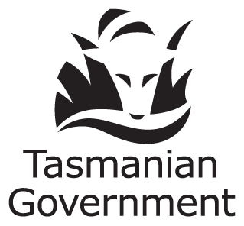 | Department of State Growth  Road Safety Branch  Towards Zero Action Plan 2020-2024  GPO Box 536  Hobart TAS 7001 Australia
 | Phone: | 6166 3243
 | Email: | rsac@stategrowth.tas.gov.au
 | Web: | www.rsac.tas.gov.au
 | © State of Tasmania June 2026

