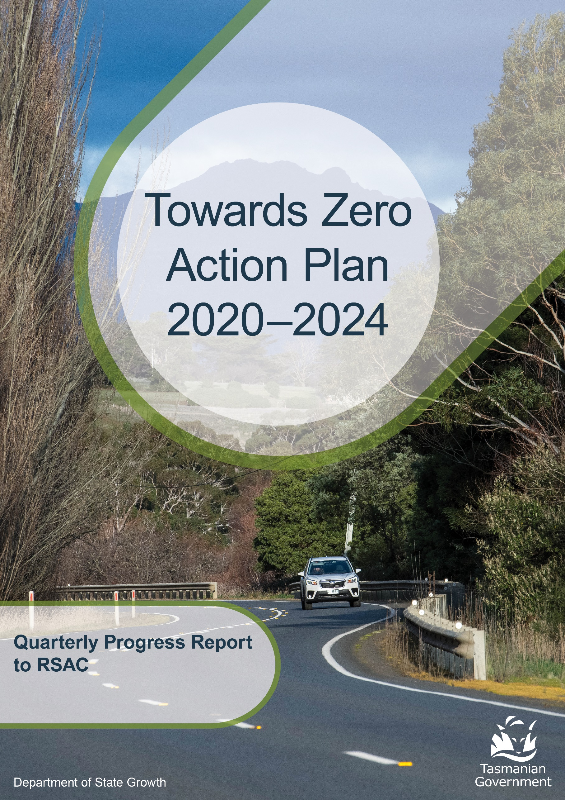

to 31 March 2026

Progress on meeting Towards Zero Strategy targets
The key interim target for the Towards Zero – Tasmanian Road Safety Strategy 2017-2026 (Towards Zero Strategy) is to reduce the number of annual serious injuries and deaths on Tasmanian roads to fewer than 200 by 2026. This is an ambitious target of 100 fewer serious casualties per year than for the period 2012-2016 (annual average) and will move us towards the long-term goal of zero serious casualties on Tasmanian roads.

Serious casualties
The number of serious casualties in 2025 was 321, compared to 339 in 2024, a 5.3 per cent decrease. The 2025 figure of 321 is a 0.6 per cent decrease on the five year serious casualty average of 322.8 (2020-2024).

Fatalities
In 2025, there were 43 fatalities on Tasmanian roads which is 12 more than the number recorded in 2024. The figure of 43 fatalities in 2024 is a 13.8 per cent increase on the five-year fatality average of 37.8 (2020-2024).

2026 YTD
There have been 86 serious casualties (9 fatalities and 77 serious injuries) to 31 March 2026, 15 fewer than the number recorded at the same time in 2025 (8 fatalities and 93 serious injuries) and a decrease of 13.7 per cent on the five year average of 99.6 serious casualties.

Statistics as @ 31 March 2026
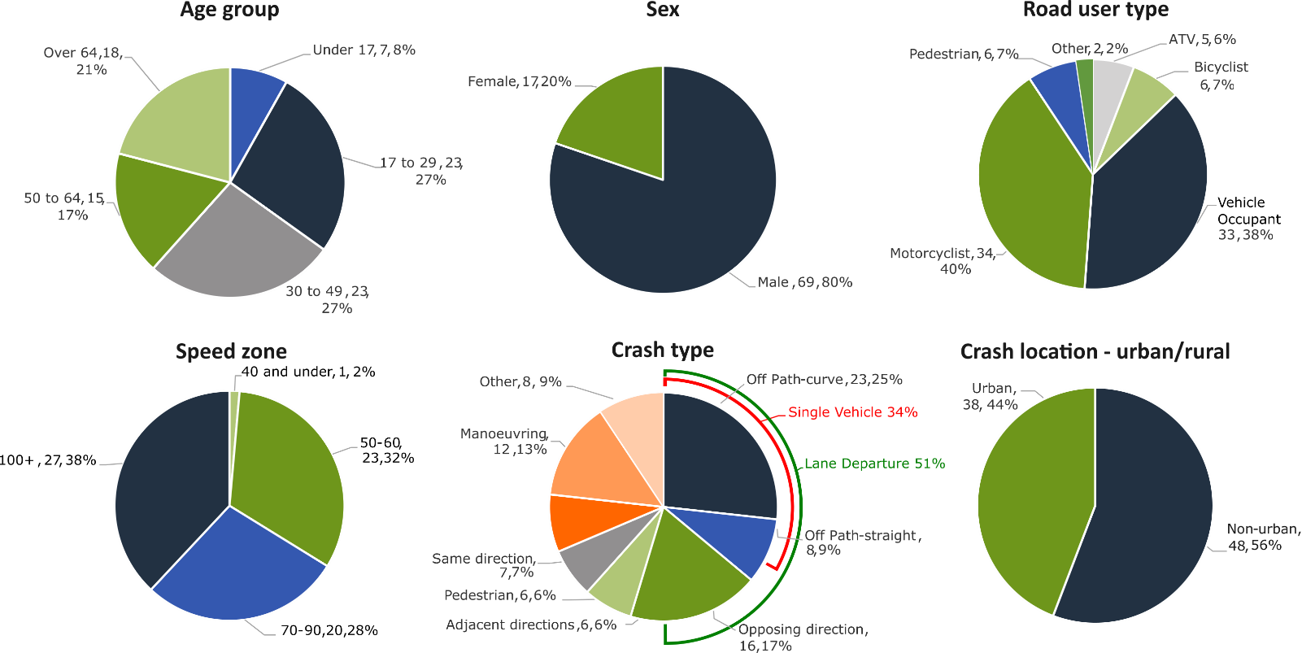

Serious casualty locations as @ 31 March 2026

(Black = Fatality, Red = Serious Injury)
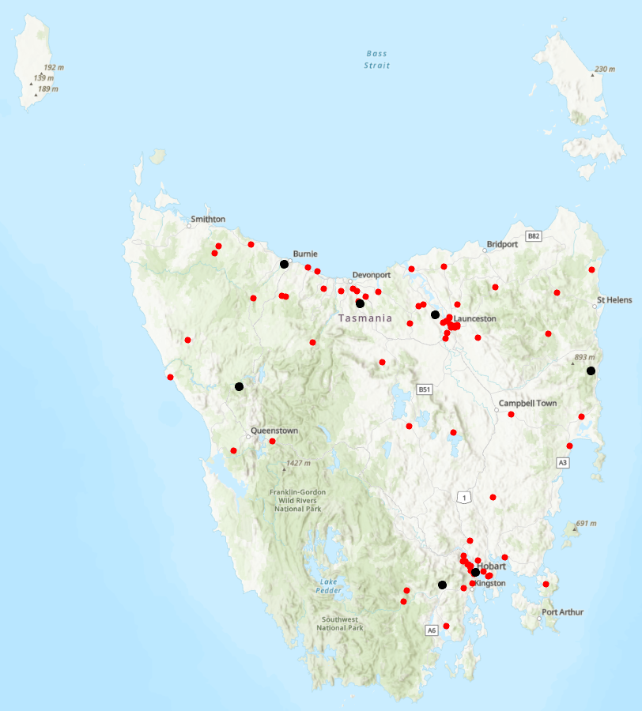

Annual Australian fatalities – Rate per 100,000 population
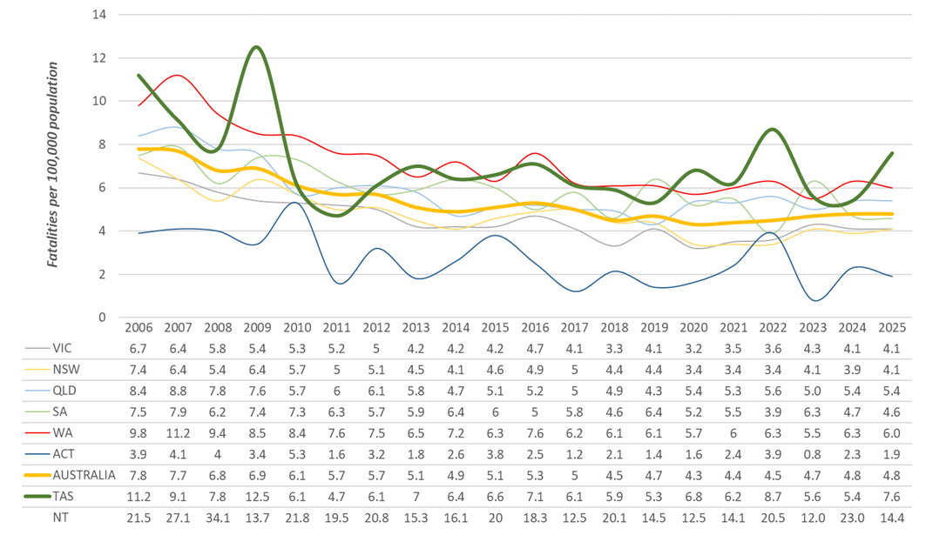

Note: NT omitted from chart for clarity purposes.
Key themes and priority actions – status report
The Quarterly Progress Report details progress on key themes and priority actions under the Towards Zero Action Plan 2020-2024 and the Towards Zero – Tasmanian Road Safety Strategy 2017-2026.
The progress report should be read in conjunction with the Action Plan and understood in the context of the Towards Zero Strategy. These documents and a project description fact sheet are available at: www.rsac.tas.gov.au

Making our rural roads safer
Rural road grants program for local government | Ongoing program |  | Infrastructure upgrades on low volume State roads | Ongoing program
Motorcyclist safety on rural roads | Ongoing program |  | Speed moderation and community engagement strategy | On schedule
Safe system knowledge and skills training | Ongoing program

Improving safety in our city and towns
Targeted infrastructure upgrades in high traffic urban areas | Not yet commenced |  | Vulnerable Road User Program | Ongoing program
Community Road Safety Program | Ongoing program |  | Trial of innovative technologies | Not yet commenced
Innovative infrastructure treatment demonstrations | On schedule

Saving young lives
Learner Driver Mentor Program and Driver Mentoring Tasmania | Ongoing program |  | Graduated Licensing System Project for drivers | Complete
Rotary Youth Driver Awareness Program | Ongoing program |  | Driving for Jobs Program | Ongoing program
RACT education initiatives | Ongoing program |  | Real Mates media campaign | Ongoing education program
Bicycle Network bike education | Ongoing program |  | Safety around schools | Ongoing program
Kidsafe child restraint check program | Ongoing program |  | Full Gear motorcycle safety project | Ongoing program
Develop a Graduated Licensing System for motorcyclists | Delayed |  | RACT Youth Road Safety Program | On schedule

Encouraging safer road use
Inattention and distraction | Ongoing program |  | Safe behaviour campaigns | Ongoing education program
Mandatory Alcohol Interlock Program | On hold |  | Protective clothing for motorcyclists | Ongoing education program
Road safety penalties review | On schedule |  | Speed enforcement strategy | Ongoing program
Enforcement of high-risk behaviours | Ongoing program |  | Automated Traffic Enforcement Program | Ongoing program
High-risk motorcycling enforcement | Ongoing program |  | Road Rules Awareness | Ongoing education program

Making visitors safer
Tourist road safety signage program | On hold |  | Responsive electronic signage trial | Not yet commenced
Tourist education materials | Ongoing education program |  | Strategic partnerships | On hold
Tourist education at gateway entry points | Ongoing program |  | Stakeholder alliances | On hold

Improving safety through vehicles and technology
ANCAP | Ongoing program |  | Safer cars for young drivers | Not yet commenced
Autonomous vehicle and crash avoidance readiness | On schedule |  | Workplace driver safety | Not yet commenced
Light vehicle safety strategy | On hold

Strategic planning
Development of a new road safety strategy | On schedule

Project status | No of Action Plan projects
Complete | 1
On schedule | 6
Ongoing program/project | 26
On hold/major delays | 6
Not yet commenced | 5
Total | 44

Key project milestones
Speed management and community engagement strategy
A final draft of the Speed Management Strategy has now been completed. The Strategy includes a principles-led framework to reduce road trauma through transitioning to safer vehicle travel speeds for Tasmanian roads and streets. There are six action areas with 28 draft actions covering community engagement, infrastructure, speed limits, enforcement, vehicle technology and partnerships.
A dedicated Implementation and Evaluation Plan has been developed to guide delivery of the Strategy. The Plan sets out how the Strategy’s actions are being delivered and how progress is monitored over time. This includes establishing safety performance indicators (SPIs) and identifying data sources. Work is continuing to finalise a Community Engagement and Communications Plan to support the implementation of the Strategy. It will include key messages linked to Strategy action areas and align with the sequence of actions set out in the Implementation and Evaluation Plan. It will provide content to guide road authorities and managers, practitioners and road safety partners by providing a consistent set of safe speed key messages.
RACT Youth Road Safety Program
A 4-year Grant Deed for the remaining term is currently being executed. The agreed plan and budget for the first year of the new Deed will be approved by the Steering Committee at the April 2026 meeting.
The project continued to work with RAC (WA) on the Supervisor/Learner App development with an aim of testing in July 2026 - September 2026.
The project worked with young people and The20 to develop a name and identity for the program which will be presented to the Steering Committee in April 2026.
Recruitment is now complete for an Education Specialist for the project and a meeting was held with the Education Reference Group for their input on approach and prioritisation.
The Social Return on Investment evaluation continued this period, however one component of the scope (Learner Driver Mentor Program (LDMP)) has been delayed due to some limitations with the primary data. Following from consultation with senior Department of State Growth representatives, the project has agreed to a variation from Social Ventures Australia so that the evaluation can maintain a thorough approach and address data gaps through some additional work directly with LDMP programs. State Growth expressed a desire for a comprehensive review in favour of a reduced scope, and the report will now be delivered late August/September, subject to support from the LDMP coordinators. Findings on the other two programs (Driving for Jobs and Northwest Driver Mentor Program) will be available as originally scheduled in June 2026.
Innovative infrastructure treatment demonstrations
In February 2026, new line markings were installed at two rural corners in Tasmania as part of a national trial of Motorcycle Perceptual Countermeasures (PCMs). These treatments aim to improve motorcycle safety by creating a visual corridor to assist riders in navigating curves. Trial outcomes are expected in early 2027.

Key project delays/on hold/not yet commenced
Targeted infrastructure upgrades in high traffic urban areas
This initiative has not yet commenced and will be considered as part of the next action plan.
However, funding allocated to this initiative to date, under the Action Plan, has supported the Road Safety Levy co-contributions under the Australian Government’s Road Safety Program (RSP). This has taken advantage of the opportunity that Australian Government co-funding has presented for targeted shoulder sealing and junction upgrades across Tasmania, and the upgrade of nearly 600 electronic school zone signs across approximately 220 locations.
Motorcyclist Graduated Licensing System (MGLS) review
The RSAC endorsed a package of recommended changes to the motorcyclist GLS. These changes will be considered by the Minister for Infrastructure and Transport. Once approved implementation will commence and regulatory amendments will be prepared.
Mandatory Alcohol Interlock Program (MAIP)
A review of the MAIP will be considered under the next Road Safety Strategy which is currently being developed.
Tourist road safety signage program
A review of road safety signage around the State is being undertaken to identify opportunities for updated road safety messaging, but is currently on hold.
Responsive electronic signage trial
This project will trial a responsive electronic sign with real time information at regional tourism gateways but has not yet commenced.
Strategic partnerships
Developing strategic partnerships based on synergies with target audiences will enable the effective promotion of tourist road safety messages and education. This project is currently on hold.
Stakeholder alliances
Sharing information and collaborating to develop effective strategies and tools to address road safety issues is vital. This project will develop formal and informal stakeholder alliances to encourage input and create opportunities to deliver joint initiatives. This activity is currently on hold.
Light Vehicle Safety Strategy
A draft Light Vehicle Safety Strategy is being prepared and will be considered under the next road safety strategy.
Safer cars for young drivers
This project has not yet commenced and will be considered as part of the Light Vehicle Safety Strategy.
Workplace driver safety
Vehicle use in road traffic is the most significant contributor to work-related traumatic injury. This project will aim to promote and encourage employers to adopt safe driving policies based on the WorkSafe, ‘Vehicles as a workplace’ guide.
This project has not yet commenced and will be considered as part of the next road safety strategy.

Funding
Road Safety Levy overview for the financial year 2025-26
As at 31 March 2026 (Quarter 3)
Road Safety Levy Opening Summary
Opening Balance as at 01 July 2025 |  |  | $32,531,179
Annual Allocation to Road Safety Operations |  |  | $ -2,600,000
Revenue Summary
 |  | Forecast (FY26)  $ | Actual (YTD)  $
Motor Accident Insurance Board Funding |  | 1,631,149 | 1,203,259
Revenue Inflows from Registrations |  | 20,341,456 | 15,341,456
Funds Available for Distribution |  | 51,903,784 | 49,075,894
Expenditure Summary
Theme no. | Theme | Budget  (FY26)  $ | Actual (YTD)  $
1 | Making our Rural Roads Safer | 6,265,343 | 2,231,445
2 | Improving Safety in our Towns and Cities | 6,757,059 | 4,192,293
3 | Saving Young Lives | 2,957,074 | 2,710,357
4 | Encouraging Safer Road Use* | 4,176,802 | 2,353,819
5 | Making Visitors Safer | 150,000 | 112,456
6 | Improving Safety Through Vehicles and Technology | 101,417 | 101,417
7 | General Support | 956,451 | 463,252
Budget and Expenditure by Category |  | Forecast  (FY26)  $ | Actual (YTD)  $
Infrastructure Expenditure |  | 11,306,776 | 5,624,958
Policy & Projects Expenditure* |  | 11,688,519 | 6,540,081
Total Expenditure |  | 22,995,295 | 12,165,040
Balance as of 31 December 2025 |  |  | 36,910,854
Forecast Closing Balance of FY26 |  | 28,908,489
*includes MAIB expenditure

MAIB Funding
As at 31 March 2026 (Quarter 3)

2025/26 Financial Year | Budget  $ | Actual (YTD)  $ | Balance  $
Expenditure (State Growth)
Administration & Public Relations | 300,633 | 215,926 | 84,707
Public Education | 1,260,516 | 942,584 | 317,932
Research | 70,000 | 44,750 | 25,250
Subtotal | 1,631,149 | 1,203,259 | 427,890
Expenditure (Tasmania Police)
Salaries | 2,424,163 | 1,846,875 | 577,288
Operating Expenses | 207,500 | 124,412 | 83,088
Equipment | 589,220 | 264,489 | 324,731
Subtotal | 3,220,883 | 2,235,775 | 985,108
Total

 | Department of State Growth  Road Safety Branch  Towards Zero Action Plan 2020-2024  GPO Box 536  Hobart TAS 7001 Australia
 | Phone: | 6166 3243
 | Email: | rsac@stategrowth.tas.gov.au
 | Web: | www.rsac.tas.gov.au
 | © State of Tasmania March 2026

